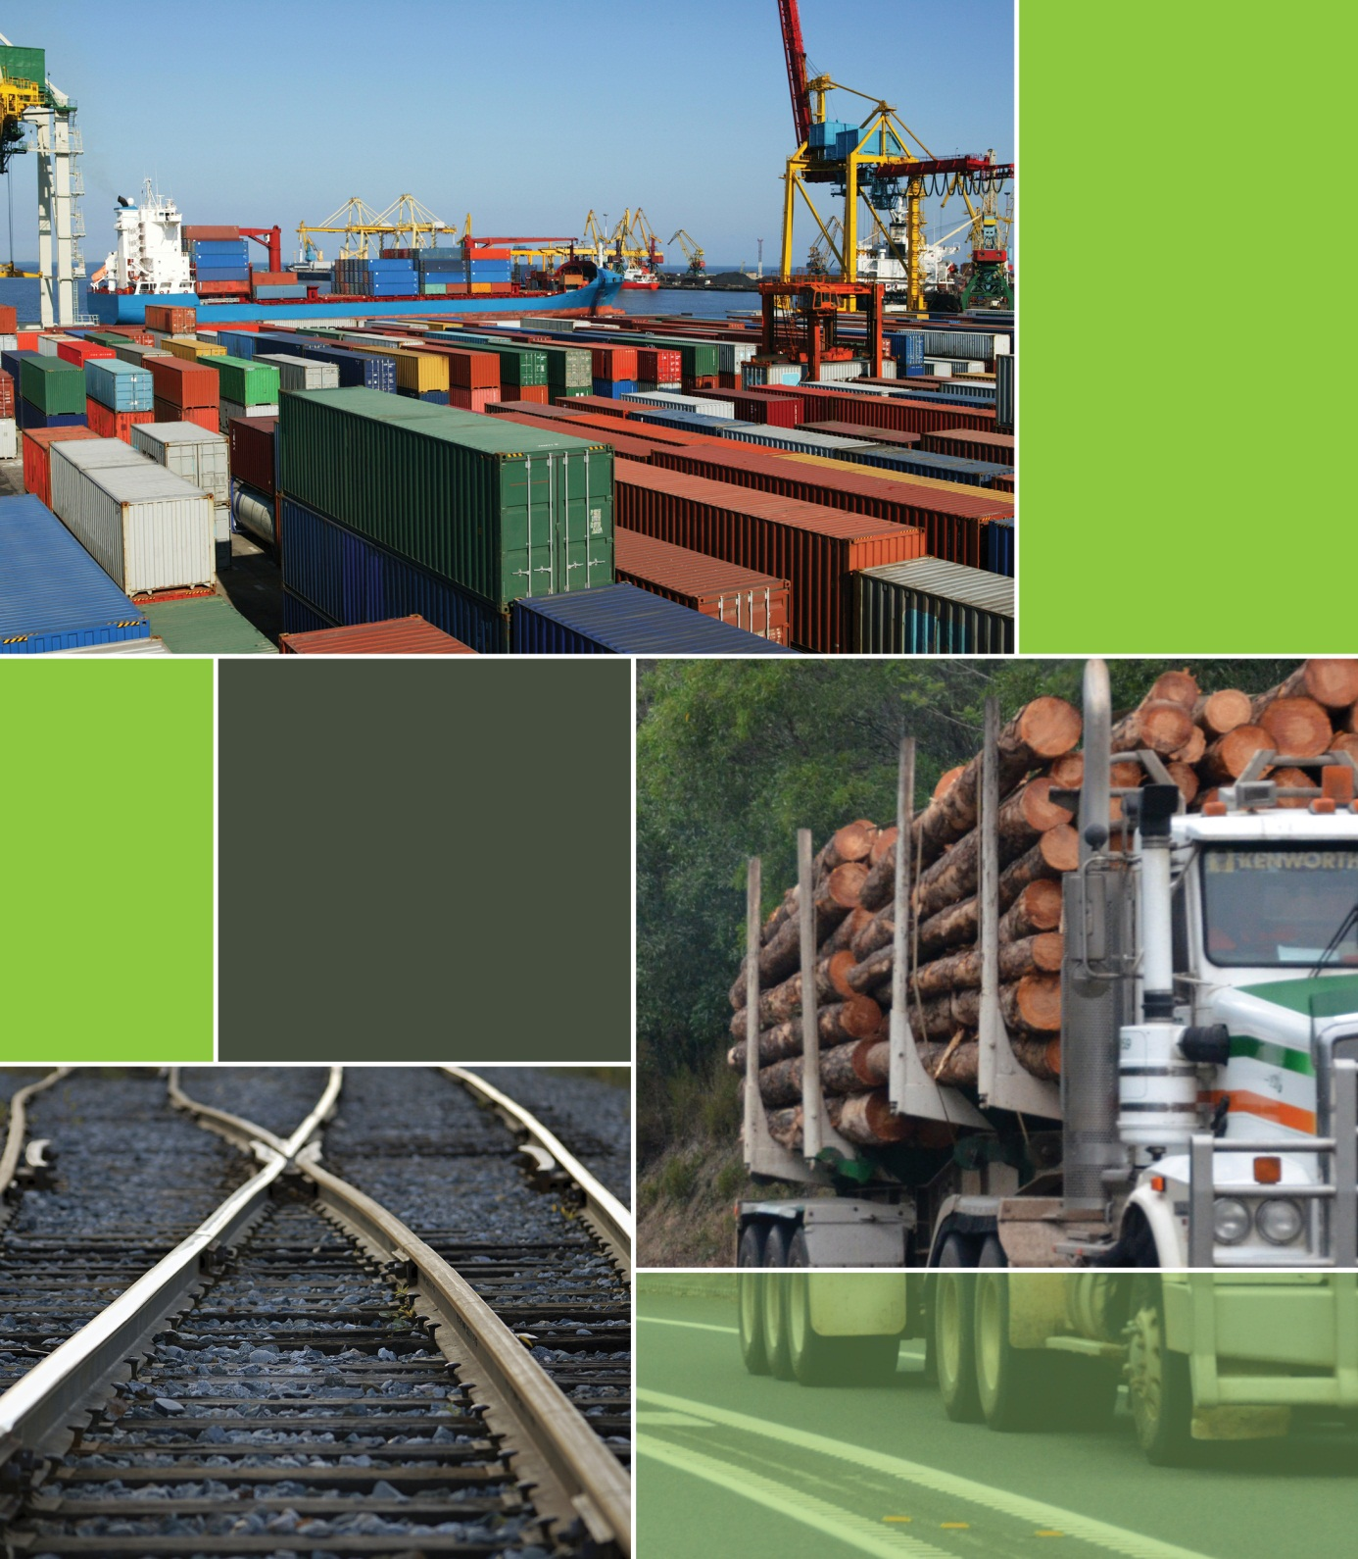

|  |  |  |
| --- | --- | --- |
|  | **Project:** Freight Logistics Coordination Team Major Consultancy Support to Work Program  Supply Chains in Tasmania | Reference: 234986  **Prepared for:** Department of Infrastructure, Energy and Resources  Revision: 0  30 August 2013 |

Document Control Record

Document prepared by:

Aurecon Australia Pty Ltd

ABN 54 005 139 873

Aurecon Centre  
Level 8, 850 Collins Street  
Docklands VIC 3008

PO Box 23061  
Docklands VIC 8012

Australia

|  |  |
| --- | --- |
| **T F E W** | +61 3 9975 3000 +61 3 9975 3444 melbourne@aurecongroup.com aurecongroup.com |

A person using Aurecon documents or data accepts the risk of:

1. **Using the documents or data in electronic form without requesting and checking them for accuracy against the original hard copy version.**
2. **Using the documents or data for any purpose not agreed to in writing by** Aurecon**.**

|  |  |  |  |  |  |  |
| --- | --- | --- | --- | --- | --- | --- |
| **Document control** | | | | | | |
| **Report Title** | | **Supply Chains in Tasmania** | | | | |
| **Document ID** | |  | **Project Number** | | **234986** | |
| **File Path** | | **P:\IND\234986 DIER - Freight Logistics\report\234986 DIER - FLCT Supply Chains in Tasmania 20130802.docx** | | | | |
| **Client** | | **Department of Infrastructure, Energy and Resources** | **Client Contact** | | **Department of Infrastructure Energy and Resources** | |
| **Rev** | **Date** | **Revision Details/Status** | **Prepared by** | **Author** | **Verifier** | **Approver** |
| **0** | **24 May 2013** | **Initial Draft** |  | **MS/NDS/NP** |  | **PC** |
| **1** | **01/08/2013** | **Draft for FLCT review** |  | **MS/NDS/NP/PC** | **SM** | **PC** |
| **2** | **12/09/2013** | **Internal Review** |  | **MS/NDS/NP/PC** | **KK** | **PC** |
|  |  |  |  |  |  |  |
| **Current Revision** | | **0** | | | | |

|  |  |  |  |
| --- | --- | --- | --- |
| **Approval** | | | |
|  |  | **Approver Signature** |  |
|  |  | **Name** | **Peter Carney** |
|  |  | **Title** | **Supply Chain Manager** |

**Disclaimer**

This report has been prepared solely for the benefit of the Freight Logistics Coordination Team (FLCT) and in accordance with instructions given by or on behalf of the FLCT and in the circumstances which existed at the time of preparation. It is not possible to make a proper assessment of the report without a clear understanding of the terms of engagement under which the report has been prepared, including the scope of the instructions and the directions given to and the assumptions made by those who prepared the report. The report may not address issues which would need to be addressed if the particular intention, environment, circumstances, time, requirements and brief are different from those for which this report has been prepared. This report may also make assumptions about matters which a third party may not be aware. It should not be used or relied upon or used for any other project or in a different set of circumstances and requirements without an independent check being carried out as to its suitability, relevance or accuracy. Aurecon accepts no responsibility or liability for the consequences of the report or the information contained therein being used or relied upon for a purpose other than the purposes for which it was commissioned at the time of the commissioning or for any unauthorised use by its client or any third party.

The information in this report has been collected through detailed interviews with industry, peak organisations and infrastructure providers. The information collected includes both business-related data and the confidential views of participants. Confidentiality of discussions and the aggregation of data and views were key components supporting stakeholder participation.

# Contents

Contents 2

1. Executive Summary 5

1.1. Background 5

1.2. The Nature of Tasmania’s Supply Chains 5

1.3. Findings 6

1.4. Recommendations 8

2. Tasmania’s Freight System and Container Freight Profile 9

2.1. Tasmania’s Freight Task 9

2.1.1 Tasmanian Economy and Population 9

2.1.2 Regional Focus 9

2.1.3 Current and Future Freight Task 11

2.2. Tasmania’s Freight System 14

2.2.1 Road 14

2.2.2 Rail 15

2.2.3 Sea 17

2.2.4 Air 19

2.3. Tasmania’s Container Freight Profile 19

2.3.1 Inbound Container Freight Task 21

2.3.2 Outbound Freight Characteristics 22

3. Supply Chain Quality and Cost Benchmarking 24

3.1. Supply Chain Definition 24

3.2. Approach 25

4. Supply Chain Analysis 27

4.1. Aquaculture (Salmon and Ocean Trout) 28

4.2. Meat (Chilled and Frozen) 32

4.3. Bell Bay Industrial Minerals 35

4.4. Beer 39

4.5. Vegetables (Fresh, Export and Frozen) 41

4.6. Fruit 46

4.7. Zinc 48

4.8. Newsprint 51

4.9. Timber 54

4.10. Dairy 56

4.11. Retail 60

5. SIW Distribution Centre (DC) 60

6. Representative Supply Chains 64

6.1. Supply Chain Quality: Summary of Comments 66

6.2. Fresh 67

6.3. Low Cost – via Melbourne 69

6.4. Low Cost – Direct Export 71

6.5. Low Inventory 72

6.6. Perishable 74

6.7. Empty Containers 75

7. Review of Tasmanian Supply Chain Costs 76

7.1. Road Freight Services and Rates 77

7.2. Rail Freight Services and Rates 78

7.3. Sea Freight Services and Rates 79

7.3.1 Indicative Shipping Rates 79

7.3.2 Volume Variation in Shipping Rates 80

7.3.3 Empty Container Positioning Costs 81

7.4. Port Costs 82

7.5. Tasmanian Freight Equalisation Scheme 83

7.5.1 Structure 83

7.5.2 TFES and Exports 85

7.6. Medium Volume Shipper Breakdown of Prices 86

7.7. Export 87

7.8. Cost Benchmarking 88

8. Findings 93

8.1. Supply Chains 93

8.2. Innovation 93

8.3. Efficiencies 94

8.4. Inefficiencies 94

8.5. Excess Empty Containers 95

8.6. Freight Service 96

8.7. Shipping Capacity 96

8.8. Freight Costs 97

8.9. Export Freight Costs 97

8.10. Data Availability 98

8.11. Market Structure 98

9. Opportunities for Improvement 99

9.1. Capacity Expansion for Shipping 99

9.2. Shipping from Bell Bay 99

9.3. Empty Container Positioning 99

9.4. Freight Data Base 100

9.5. Supply Chain Optimisation 100

9.6. Industry Structure 100

9.7. Innovation Forums 101

9.8. Assistance for Export 101

10. Appendices 102

List of Tables and Figures 103

Commodity Classifications 105

References 107

Companies Contacted 109

# 

# Executive Summary

## Background

The Freight Logistics Coordination Team (FLCT) was established as part of a one-off $20 million Australian Government funding package to assist Tasmanian exporters following the cessation of international container shipping services to Tasmania in 2011.

The FLCT is an independent expert advisory body comprising 19 senior representatives from major shippers and producers, infrastructure providers, freight logistics companies and peak industry bodies. The FLCT has a clear focus on outcomes that deliver improved freight efficiency for Tasmanian businesses, and support business growth.

As part of the FLCT’s work, Aurecon was engaged to undertake a major study on supply chain quality, cost and benchmarking. The objectives of this study are to undertake a detailed analysis of:

* transport and logistics supply chains across key commodity groups and benchmark them in terms of quality and cost; and
* the cost of shipping as a modal component of the supply chain.

Consistent with these objectives, the outcomes of the study are presented in two reports:

1. *Tasmanian Supply Chains*

Aurecon examined the supply chains of all major non-bulk commodities produced within Tasmania, and provided quantitative information and expert qualitative observations on the costs, quality and efficiency of supply chains at both an individual and aggregated level. The study has involved detailed interviews with a wide range of freight users and stakeholders, supported by site visits, analysis of freight and cost data and our own industry knowledge.

1. *Tasmanian Shipping and Ports*

This report examines shipping as a modal component of Tasmania’s supply chains, including cost, capacity and the relative efficiencies of Bass Strait shipping services and Tasmania’s three northern ports. It also investigates the underlying cost considerations to vessel owners which form the basis of freight rates and considers the potential for the resumption of direct call international shipping services to Tasmania’s north coast.

## The Nature of Tasmania’s Supply Chains

Tasmania’s economy relies on demand from larger interstate and international markets due to the small size of local demand for most products. It is also reliant on imports to supply many industry and community needs, particularly retail goods. Tasmania’s physical separation from interstate and international markets creates a dependency on Bass Strait shipping (unlike other states where there are road or rail alternatives) for which efficiency and cost is critical.

The majority of inbound freight is made up of retail market segment goods and empty containers. The retail goods are consumed by Tasmanians while the empty containers are brought in to be filled with goods and produce destined for export markets.

The supply chain for retail markets necessarily follows population centres. Goods are shipped to distribution centres (DCs) in Hobart, Launceston, Devonport and Burnie and delivered to end markets. Freight forwarders such as Toll, SeaRoad, Fresh Freight and SRT manage these freight flows.

With overnight delivery from Melbourne 7 days per week, goods can reach Tasmania in a short time. Goods ordered in the morning of one day can be on supermarket shelves by the afternoon of the next day.

Outbound freight has a different pattern to inbound freight. Tasmania’s industries and farms produce a range of products from high value seafood and berries to minerals and other commodities, such as paper. They have in common a “make and ship” supply chain. Only small amounts of the output of Tasmania’s farms and industries are held in Tasmania. Most output is held on the mainland, closer to end markets (for manufactured goods) or simply delivered directly to end markets (for fresh goods).

The Tasmanian freight system has evolved to support this “make and ship” business model. The reverse is also true as some business models have evolved to take advantage of the freight service.

Outbound freight is transported from production and harvest/processing locations to a port. These are largely (but not entirely) point to point supply chains (that is, there are no intermediate stops). Being point to point there is not a lot to improve, as once goods are on a truck or train their movement is efficient.

The area to look for improvement in Tasmania’s freight system is therefore at the system level. It is the manner and nature of interactions between supply chains where improvements may be found.

## Findings

The key findings of this study are:

* Tasmanians are well served by their shipping providers. An efficient, timely, reliable and frequent service is provided by three shipping providers. The existence of three providers is a benefit in itself as it enables a degree of redundancy in the system should interruptions occur.
* Individual supply chains, as a result of good shipping services and coordinated transport services to meet shipping, are very efficient. Goods produced from almost anywhere in Tasmania on one day are able to be shipped that evening and delivered into mainland markets by the following day.
* Tasmania’s roads are largely uncongested, which is a benefit to freight users.
* Tasmanian businesses have adjusted their supply chains to take advantage of the frequency and reliability of freight services. While only a small percentage of freight users (15%) need an overnight service, about half of the freight (51%) from Tasmania takes advantage of it.
* As good as the service is, it is a one size fits all offering and this does not always suit. Some Tasmanian businesses derive no particular value from an overnight shipping service, but in the absence of an alternative must pay for this service level and use these services.
* Transport companies have invested and are continuing to invest to improve their equipment and facilities to service Tasmanians. Examples of investment include new truck fleets, new container forklifts, capital expenditure at ports and new depots.
* Similarly, the Government is investing to improve infrastructure, notably in rail, road and at intermodal terminals.
* In benchmarking shipping costs, we found that Bass Strait shipping is 24% more expensive than a similar European service. It should be noted, however, that input costs of Bass Strait freight providers (labour costs and fuel) are estimated to be around 23% more expensive than European costs.
* The benchmark Hobart to Melbourne cost of shipping is $1,403/TEU. With TFES assistance this can reduce to $853. A comparable journey on the mainland using road transport costs between $564 and $799.
* In benchmarking road freight costs we found that Tasmanian road freight is priced similarly to mainland road freight. An indicative freight rate is $1.09/TEU/km. We found there are several road freight providers and that this market is competitive.
* As with all industries, freight pricing follows volume and volatility. Freight users with low volumes or who have highly seasonal requirements will pay more than large volume steady producers. We understand large freight users enjoy considerable discounts to nominal rates.
* TFES is a major benefit for domestic shippers who qualify for assistance. The cost of freight can be reduced to between one-third and one half of the usual wharf to wharf costs.
* Exporters from Bell Bay face significantly higher costs following the cessation of direct shipping. Goods must be transported from Bell Bay to either Devonport or Burnie and empty containers must be relocated to Bell Bay. These steps add to complexity and cost. We estimate the additional cost to be $1,000-$1,300 more per TEU.
* Individual industries and businesses are innovative. For example, for one confectionary manufacture business there has been a reduction in costs and improved service through shortening lead times, removing logistics steps, improving asset utilisation and introducing automation where appropriate.

There is evidence of planning shortcomings across Tasmanian supply chains and this is where opportunities for improvement lie.

* The movement of empty containers appears to be excessive with more than 25% of the total freight task being empty containers.
* Sourcing empty international shipping containers can be difficult. Tasmania faces an imbalance of freight. Fewer international imports arrive than leave Tasmania, which means that empty containers must be brought in. Shipping providers always favour full containers over empties and when capacity is tight fewer empties are shipped.
* Bass Strait shipping is capacity constrained at times. In the lead up to Christmas it can be difficult to move freight inbound and around harvest time in Tasmania (from February to May) some freight is not shipped because of capacity constraints.
* The availability of freight data is scarce. Reliable and reportable data does not exist in the public domain at a level that is helpful for analysis of the freight system.
* There are competing plans for the development of Tasmanian ports. Some interests wish to see Bell Bay developed, whilst others advocate for development at Burnie. The existence of competing development plans creates uncertainty for business investment.
* Shipping options are constrained. Should rail be the preferred form of linehaul from Hobart, as is the case with heavy freight, the only shipping option is to send freight via Burnie.

## Recommendations

* An increase in shipping capacity is recommended, given that shipping capacity is near its practical limit and that this is adversely affecting freight services at present.
* Weekly RORO shipments for freight from Bell Bay by one of the existing shippers should be considered. A substantial market for freight exists in Bell Bay which does not require a daily service. Direct shipping from Bell Bay would save the cost of a road leg and simplify logistics. It would also provide an alternative port for heavy freight that travels on rail.
* A clear strategy on Ports is required. We understand that this is currently in development.
* Empty container repositioning should be investigated. In addition, to the impact of these containers on Bass Strait Shipping capacity, re-positioning empty containers presents a notable cost to freight users. There may be a case for pooling containers.
* Consideration should be given to the state wide planning of freight movements. Better planning offers the opportunity to reduce the carriage of empties on ships, reduce empty backhauls for trucks, intelligently route freight to rail, eliminate the stranding of freight and reduce the number of vehicles on roads.
* With agriculture on the verge of significant expansion in Tasmania, it may be appropriate to commence down the path of co-operative industry structures to achieve economies of scale, as has been achieved in New Zealand. New Zealand presents some compelling models of effective co-operative systems. There are examples of single desk marketing initiatives (Zespri, ENZA) which have also influenced growing, product development, freight purchasing and distribution.
* We consider there is the opportunity to share examples of innovation in supply chain and logistics with others in Tasmania. Innovation tends to be held within company walls. Where businesses do not compete with each other, a forum of interested peers could meet with an innovation agenda in mind.
* Consideration should be given to measures to assist export freight users. Over time expenditure on direct freight assistance could be diverted to infrastructure improvements that improve the competitiveness of the supply chain.

# Tasmania’s Freight System and Container Freight Profile

This section provides an overview of Tasmania’s freight system and container freight profiles as background context for the supply chain analysis review.

## Tasmania’s Freight Task

### Tasmanian Economy and Population

Tasmania has a small economy, and a small, highly dispersed population. Due to the small size of local demand, the economy relies on trade with interstate and international markets as a major source of income. Major industry sectors for the State are manufacturing, mining, agriculture, fisheries, forestry and tourism.

As an island, air and sea links to access markets are essential. Around two thirds of Tasmania’s total freight task comprises goods moving in to or out of the state. The majority of container movements out of Tasmania are destined for domestic markets. Imports are vital for industry inputs and consumer goods not produced locally.

The Tasmanian economy is currently undergoing a period of structural change driven by a downturn in traditional industries such as forestry. Tasmanian Treasury forecasts indicate Tasmanian Gross State Product is expected to grow at a rate of 1.75% in the short term and at a rate of 2.25% per year in the medium term.

The current population is just over 500,000. Population projections for the State indicate a moderate population growth over time with growth focused in urban areas. Tasmanian Treasury forecasts indicate Tasmania’s population growth will remain steady at 0.4 % in 2012-13, increasing to 0.5 % for 2013-14 and subsequent years. Growth will be highest in Greater Hobart. Launceston is forecast to grow in line with overall population growth rates, with lower growth in the Burnie-Devonport region.

Economic activity underpins demand for transport infrastructure. Forecast population growth and growth in key sectors of the economy such as agriculture and mining will lead to increased demand for freight movement over the next 30 years. Detailed assessment of future demand across key industry sectors, together with analysis of current and likely future infrastructure constraints will drive the long term supply strategies for Tasmania’s transport infrastructure.

### Regional Focus

Tasmania’s freight task has a clear regional element. Each major region – North West, Northern and Southern - is a significant origin and destination for freight. The diverse location of primary production, processing and industrial centres, and major industries, together with multiple major population centres, are some of the drivers supporting a high regional task. Significant volumes of freight move between regions as well as from regions direct to a sea or air port. Key characteristics and relationships are described below.

*North West Tasmania*

* Tasmania’s largest freight generating region.
* Primary production – major agricultural region suited to high intensity dairy, vegetable and livestock production. Rapid expansion of aquaculture on the West Coast.
* Processing facilities – supporting primary production several major dairy, vegetable and livestock processors are located in the North West.
* The mineral rich west coast generates mineral ores both for export and processing within Tasmania.
* Cement production at Railton generates high but localised freight volumes.
* Containerised freight enters Tasmania through the ports of Burnie and Devonport, with a large proportion of this moved to the major population centres of Hobart and Launceston.
* Forestry – undergoing structural change, however the North West contains significant plantation resources.

*Northern Tasmania*

* Primary production – a range of agricultural commodities are produced, focused mainly on the local government areas of Northern Midlands, Meander Valley, Dorset and Flinders Island.
* A large proportion of agricultural products from the region, such as milk and vegetables, are transported to the North West region for processing and subsequent export and/or sale.
* Two major mineral processing facilities are located at Bell Bay. Mineral concentrates and some of the finished products are shipped direct, requiring minimal use of the land transport network.
* Launceston is the major administrative and retail centre and generates substantial retail demand. Several state-wide distribution centres are located in the region, including those for major supermarkets and beverage companies. A major brewery is also located in Launceston.
* Forestry – the North East contains major plantation resources. Operational timber processing facilities, including a large sawmill and export woodchip facility, are located at Bell Bay.

*Southern Tasmania*

* A large proportion of the freight generated in the Southern Region is derived from a few major industries – Nyrstar (Zinc processor), Norske Skog (paper manufacture) and Kraft (Cadbury chocolate).
* Other medium sized industries are involved in food and beverage production, meat processing, and despite a downturn over the last few years the Huon, Derwent Valley and Central Highlands still have significant forestry outputs.
* Hobart is the largest urban centre in the State and generates substantial demand for consumer goods.
* The bulk of the containerised freight destined for southern Tasmania is transported by road; however rail is used for a part of the task.
* The majority of freight moving into and out of the Southern Region is moved through Burnie and Devonport ports.

### Current and Future Freight Task

In 2008/09, Tasmania’s total heavy freight task moved on the road and rail network was around 28 million tonnes. Approximately 88% of this task was transported on road with the remainder on rail. Outside of this road/rail task it is estimated that an additional 3 to 4 million tonnes of bulk mineral ores or processed products were transported directly from ship to wharf-side processing or from mine to export location using pipeline.

The bulk of Tasmania’s freight task is generated by agriculture, construction, mining, and forestry. This is illustrated below (Figure 1), noting that mineral ores which do not use the road or rail network are not included in this figure. The forestry task has been excluded due to structural changes within the industry and uncertainty regarding future harvesting schedules and processing locations.

Figure 1: Projected net tonne per kilometre by Sector (excluding forestry) [1]

Agriculture is forecast to be a major growth area for Tasmania. The majority of agricultural production is in the North West and North of the State, with most processors located in the North West. Investment in irrigation schemes in all regions of the State, including the Southern Region is a key driver of this future growth. The majority of agricultural freight moves on the road network and, as such, roads in the North and North West are likely to experience the highest increases in agricultural freight, including the Bass Highway (Smithton to Illawarra Main Road); Bridport Main Road, Frankford Main Road, Birralee Main Road and Batman Highway (linking the North East to processors in the North West); and the Midland Highway.

Proposed expansion of existing mines and development of new mines in Tasmania has the potential to significantly increase freight from this sector over the short to medium term. In the North West, this task will largely be split between rail (Melba line), and road (primarily the Bass Highway and Murchison-Ridgley Highway corridor).

Consumer goods are forecast to undergo a large increase, but will make up a relatively small proportion of the overall task. Most consumer goods are brought into Tasmania via one of the three northern ports. Product is generally moved to urban centres via larger vehicles before being distributed to individual businesses by smaller vehicles. The rail network currently plays a key role in moving consumer goods between ports and southern Tasmania. The movement of consumer goods is likely to increase most strongly on the road and rail corridors between key container ports (Burnie and Devonport) and major urban centres (Hobart, Launceston, Burnie and Devonport).

The movement of construction materials, including bitumen, building materials, concrete, stone, sand and clay, comprise a significant part of Tasmania’s freight task (almost a quarter of the total task by tonnage in 2008/09).

Historically, Tasmania’s state and regional freight task has been dominated by forestry, with high volumes of forestry freight moving intra-regionally to one of three export ports. Market and structural changes have seen this task reduce significantly. The highest forestry freight volumes currently move out of Bell Bay reflecting the location of forestry processing centres in the adjacent Bell Bay Industrial Estate.

Figure 1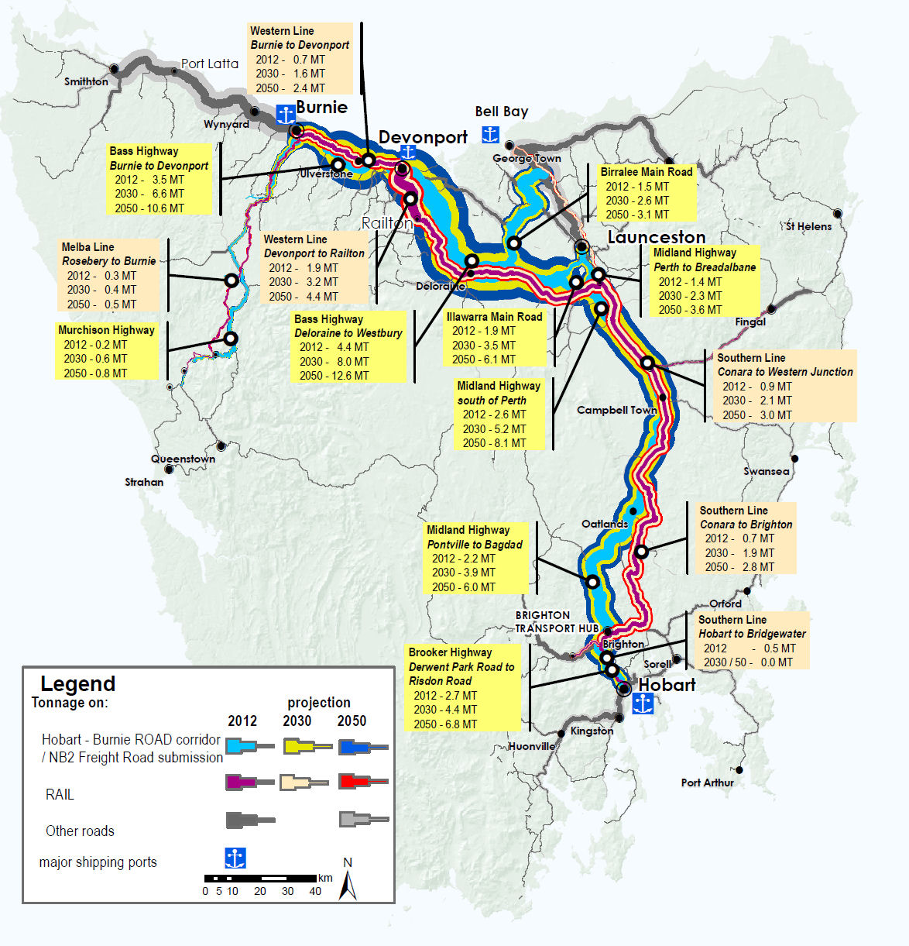2 shows forecast freight growth across Tasmania. The Burnie to Hobart corridor carries the most significant freight volumes, the majority on the road network.

Figure 2: Current and Forecast Freight Tonnages, Tasmania's Strategic Freight Network (Source DIER)

## Tasmania’s Freight System

### Road

By tonnage, traffic volumes and strategic land use connections, the Burnie to Hobart Freight Corridor is Tasmania’s most significant freight corridor, connecting major ports, processing, industrial and population centres. The Corridor extends from Burnie Port to Hobart, and includes the Bass Highway, Midland Highway, Illawara Main Road, Brooker Highway. The East Tamar Highway is another significant freight road, connecting to the Bell Bay Port and Industrial Estate.

Major regional freight roads play a critical role in moving freight to/from this key corridor, including Frankford-Birralee-Batman Freight Corridor, connecting the North East and North West regions, and Bell Bay. The Murchison Highway is the key freight link out of the West Coast, moving high-value mining product to Burnie Port for export. The highly productive North West corner of the state is connected by the Bass Highway from Smithton to Burnie port and is particularly important for the agricultural and forestry sectors.

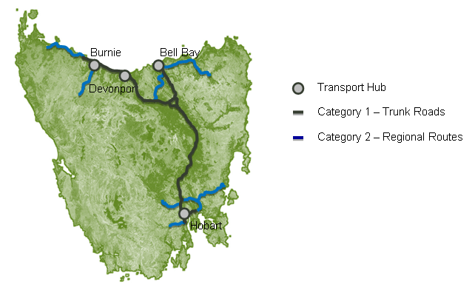

Figure 3: Tasmanian Major Road Network

Tasmania has an extensive road network, which is generally efficient, with few capacity constraints. When compared to mainland states, Tasmania has little or no congestion, with the exception of major urban corridors during peak commuter peiords. This operating environment facilities reliable freight services and provides good access to port and major freight precincts. The reliability and efficiency of the system supports just in time freight services. Added to this, the relative size of Tasmania is a unique advantage for the freight industry. For example, of the major urban centres the furthest apart is Hobart to Burnie (279km). This trip can be undertaken in approximately 3 hours 15 minutes. This is significant as it allows for a truck to be loaded at one location, transported to the other, unloaded and then repacked with a new load and then transported to the original location within a regular working day. This is highly efficient as it removes the need for driver changes or rest breaks which are a common feature of mainland interstate travel.

Tasmanian freight is served by a number of transport providers. Some specialise in particular freight, such as refrigerated fresh food, others specialise in regional locations. The road freight task is served by a range of vehicles. Some of the most commonly used vehicles include, rigid vehicles, tautliners, refrigerated pantech, 19m semi-trailers and 26m B-doubles. Anecdotal evidence suggests that some specialised vehicles, such as a side loader, can be both expensive and difficult to access.

On arrival, inbound freight is moved predominantly by truck to distribution centres for deconsolidation. The major distribution centres are located in Devonport, Launceston, Burnie and Hobart. From these distribution centres freight is distributed to end-points. Full containers that do not need de-consolidation for customers proceed from ship to customer. The reverse flow occurs for outbound freight.

### Rail

Tasmania’s rail freight system is owned and operated by TasRail which was established as a vertically integrated State owned corporation in 2009. This followed a period of private ownership, where network and service operations were undertaken by separate entities.

Tasmania’s operational rail network consists of 632km of single line track. To facilitate two-way movement of trains, there are a number of passing loops on the network. Lengths of passing loops dictate maximum train lengths, and the Tasmanian network can generally accommodate trains between 800-900 metres long.

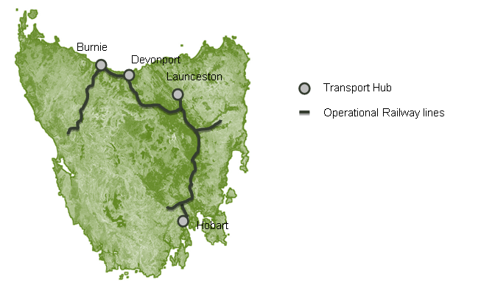

Figure 4: Tasmanian Operational Rail Network

The key link in the network is the north-south line, connecting Hobart to the northern port of Burnie. There are branch lines that join the north-south line from Fingal (located in the east), Boyer (located in the Derwent Valley in the south); and the Bell Bay Port and Launceston in the north. The Melba Line connects mines on the West Coast to Burnie Port.

In FY 2011/12 TasRail carried 1.5 million tonnes of bulk freight and 0.8 million tonnes of intermodal containerised freight.

While the majority of the State’s freight task is moved by road, rail is an important modal option for moving large volumes of bulk commodities (mineral ore, coal, and cement) and the long distance movement of containerised freight. The rail network integrates its operations with ports, road transport terminals and large industries as part of an integrated supply chain which enables improved overall efficiency and productivity of freight transport in Tasmania.

For large bulk freight tasks, rail offers the advantage of consolidating the full outbound load onto one train as opposed to several trucks. Rail offers particular benefits to businesses with loading or unloading facilities directly on the rail network, enabling minimisation of freight ‘double handling’.

The main flow of bulk freight is cement from Railton to Devonport wharf, a distance of about 26kms. Other bulk commodities are mineral ores on the Melba Line from mine locations on the West Coast to Burnie, and coal from Fingal to Railton. In 2013 TasRail commenced transport of logs between southern Tasmania and Bell Bay.

There is reasonable prospect that several mineral projects will commence operations in the short to medium term. If these projects are realised the rail system is well placed to support them with resultant growth in the bulk side of its business.

Rail also participates in the intermodal market primarily on the north-south line between Hobart and the Port of Burnie. Newsprint and Zinc Ingots make up a large part of the volume moved. For non-time sensitive products rail is an attractive proposition. Rail has approximately 10% market share of the intermodal freight in Tasmania. In this market sector rail competes with road transport.

### Sea

Tasmania relies on moving freight in and out of the state by sea through its sea ports. Each region has at least one major port involved in the shipment of bulk materials:

*South:* Hobart: movement of bulk fuel, mineral concentrate, logs and forestry products.

Prior to the forest industry downturn in 2010 a major woodchip export facility operated from Triabunna.

*North:* Bell Bay: bulk mineral concentrate, woodchips, coke, metal products and fuel.

*North West*: Burnie: bulk mineral concentrate, logs and fuel.

Devonport: cement and fuel.

Port Latta (privately owned port facility): mineral concentrate.

A large component of Tasmania’s sea freight task by volume is ‘bulk freight’ – for example, mined ore concentrates, fuel, cement and woodchips – or ‘break bulk’ – for example, un-containerised wood products. Bulk freight is largely in the domain of single companies who charter vessels to ship their particular commodity, in some cases to/from privately owned wharf facilities.

Containerised freight and freight contained in trailers forms the other major component of the sea freight task.

Table 1 shows freight flows through Tasmania’s four major ports. The three northern ports carry the highest bulk and container freight volumes, with Burnie Port catering for the highest total volumes. All three northern ports carry significant volumes of bulk freight, although the highest bulk freight volumes are moved through the privately owned facility at Port Latta (2.5 million tonnes per year).

The shipment of containerised and RORO freight occurs out of two ports – Burnie and Devonport, with approximately 240,000 and 200,000 annual TEU movements respectively. Bell Bay Port previously carried higher container volumes – around 90,000 TEU movements in 2009 – however the withdrawal of international container services through Bell Bay has seen TEU numbers fall to around 6,000 TEU in 2011/12.

|  |  |  |  |  |  |
| --- | --- | --- | --- | --- | --- |
|  | FY 011/12  (tonnes) | Burnie | Devonport | Bell Bay | Hobart |
| Forestry | 1,266,500 | 392,186 | 0 | 652,434 | 221,880 |
| Minerals Concentrate | 2,212,099 | 600,680 | 0 | 1,013,144 | 598,275 |
| Minerals Processed | 615,378 | 0 | 0 | 479,765 | 135,613 |
| Containers | 4,604,442 | 2,602,234 | 1,930,814 | 71,394 | 0 |
| Fuel | 664,663 | 130,639 | 188,255 | 65,692 | 280,077 |
| Other | 1,851,851 | 18,610 | 1,238,257 | 50,428 | 544,556 |
| **Total (Tonnes)** | **11,214,933** | **3,744,349** | **3,357,326** | **2,332,857** | **1,780,401** |
| **Total (TEU)** | **448,864** | **242,284** | **200,695** | **5,885** | **0** |
| *Source: TasPorts communication to study team, April 2012*  *Flows of ‘Minerals Concentrate’ through Burnie are mainly outbound, but generally inbound to processing plants through Bell Bay and Hobart ports.*  *‘Other’ covers the outbound flow of cement through Devonport, and processing by-products through Hobart.* | | | | | |

Table 1: Freight Task Throughput of Tasmania’s Major Ports 2011-12

Shipping services across Bass Strait are provided by SeaRoad Shipping, Toll–ANL and TT-Line. SeaRoad Shipping and Toll-ANL provide an overnight service six days per week. TT-Line provides an overnight service from Tasmania seven days per week, and has a slightly faster crossing time. Each of the service providers operate independently from their own terminals. The carrying capacity and characteristics of a typical vessel for each carrier is:

* Toll-ANL: 500 TEU plus general freight (containers, trailers, agricultural equipment, break bulk)
* SeaRoad Shipping: 180 -260 TEU plus trailers (containers and trailers)
* TT-Line: 175 TEU (trailers, cars, caravans)

We estimate monthly capacity to be 23,000 TEU. We consider effective capacity to be 85% of this figure, 19,550 TEU. Effective capacity is the capacity at which the system operates well. At this utilisation the system can recover from unplanned outages or unexpected peaks within a reasonable time frame.

Swire Shipping operates a multipurpose vessel on a 32-day rotation through to Korea and China, calling at Bell Bay for Bell Bay Aluminium cargos. This service is relatively new and picks up break bulk as well as containerised cargoes. There is a small amount of container capacity for other exporters.

The features, benefits and relative efficiencies of Bass Strait Shipping are discussed in greater detail in the accompanying report ‘Tasmanian Shipping and Ports’.

### Air

Air freight carries approximately 17,000 tonnes of freight in Tasmania annually. This represents less than 1% of Tasmania’s freight task by volume. Due to its higher cost, when compared to sea freight, use of air freight is characterised by high end, high value products. This includes a mix of perishable, time sensitive products such as abalone, crayfish, cut flowers and berries. These products are seasonal with mail underpinning the service. Air freight is not eligible for TFES assistance.

From stakeholder discussions we gathered the following information. Tasmania is a net importer of air freight with freight capacity typically full inbound. We understand that growth in internet shopping has somewhat contributed to this allied to a base load of mail and newspapers. There is typically spare capacity outbound; however, capacity is often reached at Christmas and Easter. Approximately 85% of outbound products are destined for international markets. These products can be transferred at Tullamarine airport onto international services.

Air freight services are available from Hobart and Launceston Airport. The major air freight providers are Australian Air Express and Toll. Services are provided in the belly-hold of passenger services as well as specialised freighter services. Australian Air Express (AAE) provides two dedicated freight services daily from Tasmania to Tullamarine airport in Melbourne. One flight connects Hobart and a second connects Launceston each with a capacity for 15 tonnes. Anecdotal evidence suggests that the AAE fleet could double its service if required. Discussions with a fruit industry peak body indicated a charter was considered but discounted on a cost basis when compared to TT-Line. Similar to other freight services, air freight is a dynamic offering with better service and increased frequency, but at a higher price. For example, AAE can offer a service on the next available Qantas passenger flight for a higher price or an overnight service on its dedicated aircraft for a lower price.

## Tasmania’s Container Freight Profile

Between FY2001 and FY2008, the Tasmanian economy grew at an average of 3.4%. Over the same period, TEU volumes (containerised and RORO freight) increased by 60%, representing an average annual increase of 8%.

In the four years following the FY2008 peak, total TEU declined by 9%, at an average annual decrease of 2%. Three key trends are notable over this period: the cessation of container freight through Hobart; decline in container freight volumes through Bell Bay; and consolidation and growth of container volumes through Burnie and Devonport ports.

The inbound and outbound flow of Tasmania’s container task for the last five years is shown in the tables below.

|  |  |  |  |  |  |  |  |
| --- | --- | --- | --- | --- | --- | --- | --- |
|  | | | | | | Port "Market Share" | |
| FY | **Bell Bay** | **Devonport** | **Burnie** | **Hobart** | **Total** | **Devonport** | **Burnie** |
| 07/08 | 46,372 | 87,913 | 109,970 | 2,076 | 246,331 | 36% | 45% |
| 08/09 | 45,339 | 86,782 | 103,475 | 0 | 235,596 | 37% | 44% |
| 09/10 | 22,246 | 93,840 | 114,205 | 0 | 230,291 | 41% | 50% |
| 10/11 | 24,689 | 93,282 | 115,142 | 0 | 233,113 | 40% | 49% |
| 11/12 | 2,412 | 101,341 | 121,776 | 0 | 225,529 | 45% | 54% |
| ***Source: TasPorts Annual Report FY 11/12*** | | | | | | | |

Table 2: Inbound Freight (TEU) Task and Port Market Share

|  |  |  |  |  |  |  |  |
| --- | --- | --- | --- | --- | --- | --- | --- |
|  | | | | | | Port "Market Share" | |
| FY | **Bell Bay** | **Devonport** | **Burnie** | **Hobart** | **Total** | **Devonport** | **Burnie** |
| 07/08 | 43,086 | 83,123 | 117,267 | 1,678 | 245,154 | 34% | 48% |
| 08/09 | 46,587 | 82,282 | 109,720 | 0 | 238,589 | 34% | 46% |
| 09/10 | 24,117 | 90,902 | 115,646 | 1 | 230,666 | 39% | 50% |
| 10/11 | 23,001 | 90,759 | 116,473 | 1 | 230,234 | 39% | 51% |
| 11/12 | 3,473 | 99,353 | 120,508 | 0 | 223,334 | 44% | 54% |
| ***Source: TasPorts Annual Report FY 11/12*** | | | | | | | |

Table 3: Outbound Freight (TEU) Task and Port Market Share

### Inbound Container Freight Task

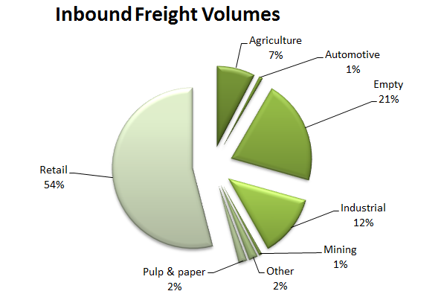The major inbound container commodities to Tasmania are retail, empty containers and industrial products.

Figure 5: Tasmanian Inbound Freight Breakdown (FY 2011/12)

The key characteristics of the inbound task are:

* 54% of inbound freight is retail products, with manufacturing goods the major commodity within this commodity type.
* The main destination for retail freight are the major population centres of Hobart, Launceston and Burnie-Devonport.
* 21% of inbound freight is empty containers.
* Less than 5% of inbound freight, or 11,000 TEU, has been transhipped as part of an international import.
* There are two major seasonal peaks: October, driven by an influx of retail goods for Christmas; and March to May, related to an inflow of empty containers for agricultural exports.

The seasonal movement of freight into Tasmania is shown below.



19550 TEU Effective Capacity

(85% 0f 23k TEU)

Figure 6: Monthly Bass Strait TEU Flow (full containers)

### Outbound Freight Characteristics

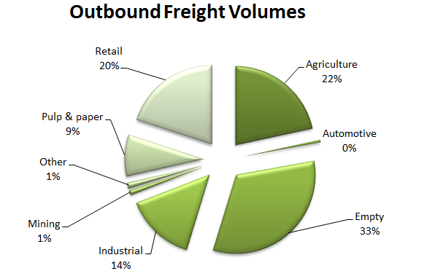The major outbound container commodities to Tasmania are empty containers, agriculture and retail, products.

Figure 7: Tasmanian Outbound Freight Breakdown (FY 2011/12)

The key characteristics of the outbound task are:

* The top four outbound commodities of empty containers, agriculture, retail and industrial products account for almost 90% of total containerised exports.
* Empty containers and trailers account for 33% of outbound freight volumes.
* Around 17% of the outbound task, or 37,000 TEU, is transshipped for international export. The major commodities within this task are zinc, newsprint, vegetables and aluminium.
* Outbound freight volumes peak between February and May, reflecting the movement of large volumes of agricultural products. The volume of agricultural exports is growing.

The seasonal movement of freight out of Tasmania is shown below.

19550 TEU Effective Capacity

(85% 0f 23k TEU)

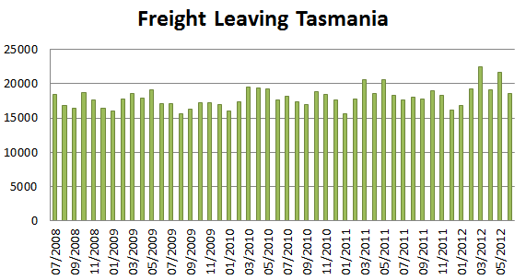

Figure 8: Monthly Bass Strait TEU Flow

## 

# Supply Chain Quality and Cost Benchmarking

The objective of this study was to analyse and better understand Tasmanian supply chains, including service and quality, and to benchmark supply chain costs against comparable Australian jurisdictions. In this context, this report focuses on:

* observations about the quality of supply chains across key commodity groups, including commentary about impediments to supply chain operations;
* an analysis of freight costs across commodity groups, with comparison to national benchmarks, where appropriate and available; and
* suggestions for improvements to the freight supply chains.

The focus of the study was containerised freight, and mostly outbound flows, however some observations on bulk freight and inbound containerised freight are made.

## Supply Chain Definition

A *supply chain* is a system of organizations, people, technology, activities, information and resources involved in moving a product from supplier to customer. Supply chains transform natural resources, raw materials and components into a finished product that is delivered to the end customer. Supply chains move products from input materials, through processing, through distribution, and ultimately to customers[2]. Each company operates its own specific supply chain, based on its own needs.

Supply chain management is a broad concept with multiple levels. Generally, it is concerned with determining the most efficient supply chain position (balancing cost, service and quality) to service a market.

Freight users make their transport choices based on time, price and reliability. Different industries have different supply chains, for example, consumer goods generally require a greater level of reliability, responsiveness and complexity than primary industry, mining or forestry.

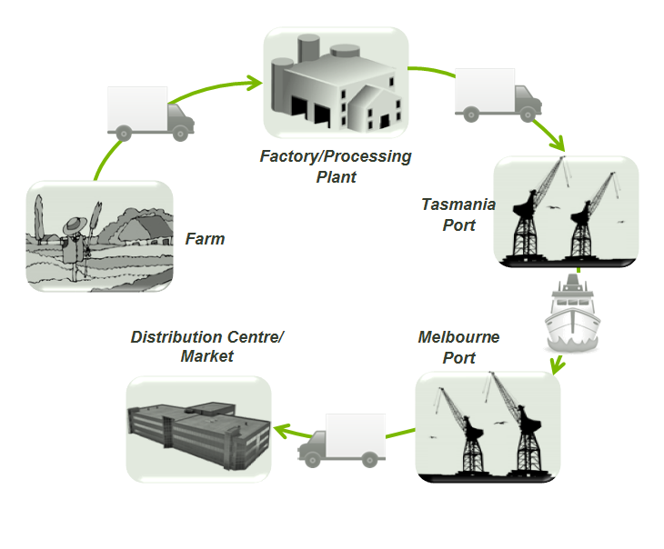Supply chain mapping identifies and analyses the steps within a supply chain, capturing the transition points or nodes and associated transport links. Figure 9 shows a typical supply chain in Tasmania.

Figure 9: Typical Tasmanian Supply Chain

Generally, the risk of supply chains problems is higher at a node, where a product may be delayed, incorrectly stored or constrained. Problems arise at nodes because there is:

* a handover of responsibility;
* some loss of information;
* a change in the capacity of the system from one process to another; or
* a change from a continuous process to a batch process or vice versa.

## Approach

Aurecon interviewed approximately 80 infrastructure providers, freight forwarders, freight providers, freight users, associations and government bodies (a list is provided in Appendix D). These organisations are involved in the production and movement of either major commodities or commodities considered to be of interest to the FLCT.

Supply chains were mapped by both individual commodity groups and representative supply chains. The latter were identified based on the key attributes of perishability, overnight delivery, time sensitivity and cost sensitivity, leading to five key groups: fresh, low-cost, low inventory, perishable and empty (being empty containers).

The individual and representative supply chains that formed part of the study are:

1. Fresh: Vegetables, Fish, Fruit
2. Perishable: Confectionery, Butter and Cheese, Misc Food, Livestock, Meat,

Frozen Vegetables

1. Low inventory: Newsprint, Paper, Misc Manufactures, Beer, Crude Fertiliser and Minerals,

Animal Foods

1. Low cost: Zinc, Aluminium, Scrap Metal, Pulp and Waste Paper, Furniture, Timber
2. Empty: Empty Containers

The steps captured within the supply chain analysis focused on location steps – ‘nodes’ – and transport steps – ‘arcs.’ This approach involves the detailed review of supply chain operations and relationships, including potential inefficiencies, multiple handling issues and the freight and logistics choices made by businesses. An example of a node and arc diagram is illustrated below.

. 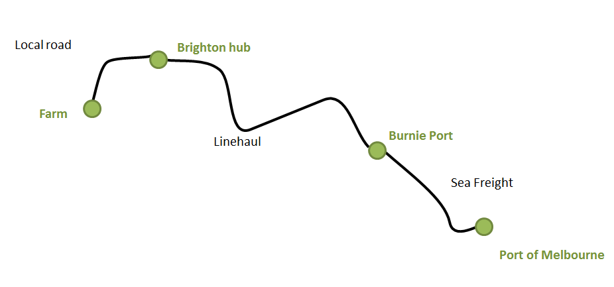

Figure 10: Sample Node Arc Diagram

Most interviews included a site visit, usually to production points, hubs, distribution centres or terminals. An important part of the process was the ability to observe business operations and capture anecdotal information.

Data on volumes, seasonality and cost was sought from individual businesses. However in the majority of interviews, freight volumes and costs were not disclosed for commercial reasons despite assurances of confidentiality within the study.

To assist in building volume data, other sources have been used including company annual reports; the Tasmanian Department of Infrastructure Energy and Resources’ (DIER) Tasmanian Freight Survey 2008-09; data from the Port of Melbourne and TasPorts; and a variety of general access documents. Indicative road freight rates were sourced from Transeco, a road freight economics consultancy. Sea freight rates were available from a small number of freight users.

To protect the confidentiality of information collected from individual businesses, representative supply chains have been used. Information is also presented at a generic commodity supply chain level but costs are not included in this analysis given the information is too easily related back to individual businesses.

# Supply Chain Analysis

Tasmania’s freight supply chains are relatively simple and similar across commodities. Most businesses operate point to point supply chains, typically using two transport modes (e.g. road and sea) as part of a ‘make and ship’ business model.

Tasmanian freight supply chains differ from mainland supply chains which involve both a linehaul and distribution function. For many Tasmanian businesses, goods are packed on site and line hauled to the mainland, then distribution occurs on the mainland.

Opportunities to improve a linehaul function are limited. Considering a commodity or business in isolation, once a product is placed on a truck there is little that can be improved.

The opportunities for improvement in Tasmania are across supply chains and at the system level, considering how supply chains work together, how freight is planned and whether networks can be improved.

This section reviews individual supply chains in terms of their operation, requirements, volumes and transport modes, supported by general observations on quality and efficiency.

## Aquaculture (Salmon and Ocean Trout)

|  |  |
| --- | --- |
| **Market** | The majority of salmon and ocean trout produced in Tasmania are sold in Australian markets. The product has a limited shelf life, making it a time sensitive supply chain.  Salmon and ocean trout are sold in various forms – whole fish (head on gutted); processed (smoked, sliced, etc); and steaks. Customers include wholesale markets, supermarkets and restaurants. |
| **Supply Chain Requirements** | The key requirements of this supply chain are responsiveness and reliability. The timing of activities in this supply chain is also important.   * Responsiveness   + Goods move quickly through the supply chain. The delivery of fresh fish to market is the key objective.   + The earlier fish are delivered, the longer the shelf life. Some supermarkets will not accept product with less than 75% shelf life. This requirement is important for fish shipped over longer distances, such as to Brisbane or Perth. * Reliability   + The supply chain needs to be robust to disruption. * Timing   + Close coordination between the harvesting and processing of salmon and ocean trout and shipping services is very important in maximising freshness. |
| **Volume** | Three companies are prominent in the industry. Indicative volumes for each are:   * Huon Group: 11 000 tonnes * Tassal: 21 000 tonnes * Petuna: 8 000 tonnes |
| **Supply Chain Steps** | The sources of salmon and ocean trout are Macquarie Harbour, Tamar River; and D’entrecasteaux Channel. Primary processing occurs near the point of harvesting. Secondary processing occurs at Margate, Huonville, Parramatta Creek and Devonport, where state of the art processing plants are located. As a fresh product, little inventory is held and most product is shipped the day it is caught, reaching market 24 to 36 hours after being caught. Some product is frozen and held in refrigerated storage.  TT-Line is key to this supply chain as its later departure, faster sailing and use of trailers enables end of day loading and start of day delivery to markets.  There are two main outbound supply chains – Dover to Devonport and Macquarie Harbour to Devonport – and these are described below.  **Dover to Devonport**  The Dover to Devonport (and onto Melbourne) supply chain starts with an early morning harvest. At Dover, salmon are stunned and bled (primary processing) before being trucked to Margate for further processing to produce head-on-gutted salmon (HOG) and sliced salmon. This stage is called secondary processing. After secondary processing fish are loaded into refrigerated trailers and transported to Devonport. There may be an additional stop in Hobart to top up the load from inventory held in cold stores.  At Devonport the product is loaded onto a TT-Line vessel, shipped to Melbourne, and transported to a warehouse in Laverton where produce is cross-docked and either despatched to customers or on-forwarded.  While there are a number of steps in the supply chain, product that is loaded at Margate generally travels to Laverton without further off-loading, avoiding re-packing. The key supply chain steps are outlined below:   |  |  |  |  | | --- | --- | --- | --- | | From | To | Mode | Step | |  |  |  | Harvest – 1am | | Dover |  |  | Primary processing | | Dover | Margate | Road | Transport | | Margate |  |  | Secondary processing | | Margate | Hobart | Road | Transport | |  |  |  | Consolidation | | Hobart | Devonport | Road | Transport | |  |  |  | Load onto vessel | | Devonport | Melbourne | Sea | Bass Strait - depart 7.30pm | |  |  |  | Unload from vessel | | Melbourne | Laverton | Road | Transfer to warehouse | |  |  |  | Deconsolidate and cross dock | |  |  | Road | Deliver to customer – 11am |   Table 4: Aquaculture Supply Chain Steps: Dover to Devonport |
| **Macquarie Harbour to Devonport**  Salmon are harvested at night, stunned, bled on barges on Macquarie Harbour, and transferred to vehicles (also on barges) for transport to Devonport. The loading of vehicles on a barge saves a re-handling step.  On arrival at Devonport the salmon are pumped from vehicles to the processing facility (located adjacent to Devonport Port) for secondary processing. The processed salmon are then loaded into refrigerated trailers, shipped via TT-Line to Melbourne, and transported to a warehouse in Laverton for sorting and customer dispatch.  One company operates a processing facility at Parramatta Creek, located just outside Devonport. For this company, there are some additional transport steps. Its arrangements on the mainland are not known.  The supply chain steps are outlined below:   |  |  |  |  | | --- | --- | --- | --- | | From | To | Mode | Step | | Strahan |  |  | Harvest – 1am | | Strahan |  |  | Primary processing | | Strahan | Devonport | Road | Transport | |  |  |  | Processing | |  |  |  | Load onto vessel | | Devonport | Melbourne | Sea | Bass Strait – depart 7.30pm | |  |  |  | Unload from vessel | | Melbourne | Laverton | Road | Transfer to warehouse | |  |  |  | Deconsolidate and cross dock | |  |  | Road | Deliver to customer -11am |   Table 5: Aquaculture Supply Chain Steps: Macquarie Harbour/Strahan to Devonport |

|  |  |
| --- | --- |
| **Arcs and Nodes** | Port of Melbourne  **40,000 tonne**  **420 km**  Dover  Huonville  Hobart  Strahan  Parramatta  Creek  Devonport  **11,000 tonne**  **226 km**  **29,000 tonne**  **300 km**  Transport Hub  Cold Store  Harvesting and Primary Processing  Secondary Processing  Major Highway  Shipping Route |
| **Seasonality** | Australians consume salmon in the warmer months. Peak to trough, the seasonal difference is about two fold. The seasonal peak adds in the order of 200 TEU per month, or 7 to 8 TEU per day, to shipping requirements. |
| **Observations** | When looking at supply chain efficiency it is common to look for double handling, utilisation and timing problems. In this supply chain there is no double handling of product - production facilities are located either at the point of harvesting or at Devonport. Locating processing facilities at these natural break points in the supply chain eliminates double handling. There is no lag time in the supply chain as deliveries are timed to meet vessel cut-off times. Trailers are reported to be fully utilised.  This market requires a fast, timely and reliable supply chain in order to deliver a fresh product to consumers on the mainland. Delivery to a customer in around 36 hours (including processing) is efficient and comparable to an equivalent high standard interstate supply chain.  The chain has no idle time. It is understood vessels will wait for a late vehicle, ensuring within reason that any cargo intended to ship will be shipped.  The supply chain is considered efficient and effective in both design and operation. |

## Meat (Chilled and Frozen)

|  |  |
| --- | --- |
| **Market** | Meat produced in Tasmania includes beef, sheep, lamb and veal. It is exported domestically and internationally as both chilled and frozen product. Export markets are broad, and include destinations in Europe, Asia, the Middle East and the USA. Hides are shipped to China.  Some product is sold locally in Tasmania, however this represents a small percentage of the volumes produced and is not reviewed here. |
| **Supply Chain Requirements** | Generally, chilled meat is sold domestically, while frozen meat is sold to international markets. As a fresh supply chain, chilled meat is time sensitive making it important this product is moved quickly to Melbourne for further processing. For frozen meat, the need for quick delivery to Melbourne is less urgent. For both chains efficiency and cost are important.  The supply chain steps differ depending on the degree of local downstream processing available and end market.  For example, one company without downstream processing facilities slaughters lamb, mutton and veal to produce chilled and frozen carcasses. Carcasses are located into refrigerated vehicles, transported to Devonport and shipped to Melbourne where carcasses are transferred to an export meat works for processing and subsequent packaging for export.  Another company with downstream processing facilities slaughters beef, lamb, mutton and veal. It then bones the meat, and packs it into cartons to be chilled and frozen. Frozen product is packed into containers on-site for export. |
| **Volume** | Three companies are prominent in the industry. Indicative volumes for each are:   * JBS Swift: 20 000 tonnes * Greenhams: 10 000 tonnes * Tasmanian Quality Meats: 5 000 tonnes |
| **Supply Chain Steps** | **Supply Chain Steps – Cressy to Melbourne – Chilled Supply Chain**  The supply chain steps are shown below:   |  |  |  |  | | --- | --- | --- | --- | | From | To | Mode | Step | |  |  |  | Slaughter animals, load onto vehicle | | Cressy | Devonport | Road | Transfer – 4pm | |  |  |  | Load onto vessel | | Devonport | Melbourne | Sea | Bass Strait – depart 7.30pm | |  |  |  | Unload from vessel | |  |  | Road | Transfer to export meatworks – 10am |   Table 6: Supply Chain Steps: Chilled Supply Chain  There are additional supply chain steps after arrival at the Melbourne distribution centre, related to further processing for sale into export markets. These steps are common to any abattoir that does not have downstream processing facilities and are not particular to Tasmanian freight. There are inefficiencies associated with these further steps (multiple handling steps). The company in question is currently investing to bring downstream processing in-house and improve this aspect of their supply chain.  **Supply Chain Steps – Longford to Melbourne – Frozen Supply Chain**  As an export supply chain, frozen meat is not as critically time sensitive as chilled meat. However the need to meet an export vessel is a key consideration.  Cartons of meat are typically shipped in 40ft refrigerated containers. This equipment is not readily available in Tasmania and needs to be re-positioned into the state. The supply chain steps are outlined below.   |  |  |  |  | | --- | --- | --- | --- | | From | To | Mode | Step | |  |  |  | Slaughter animals | | Melbourne | Devonport | Sea | Re-position food grade export container | | Devonport | Longford | Road | Transfer | |  |  |  | Pack container | | Longford | Devonport | Road | Transfer | |  |  |  | Load onto vessel | | Devonport | Melbourne | Sea | Bass Strait | |  |  |  | Unload from vessel | |  |  |  | Transfer to export berth |   Table 7: Supply Chain Steps Longford to Melbourne – Frozen Supply Chain |
| **Arcs and Nodes** | Transport Hub  Production  Major Highway  Shipping Route  Port of Melbourne  420 km  **Roadfreight**  **25 000 tonne**  Smithton  Longford  Cressy |
| **Seasonality** | Outbound volumes are around 300 TEU/month, with a peak of 350 TEU per month. |
| **Observations** | There appears to be considerable double handling of meat in the Cressy supply chain after arrival in Melbourne. This adds to cost and is a catalyst for further enhancement of facilities.  In the Longford supply chain, containers are packed at the point of production and shipped to end markets (in this case, for export). There is no double handling of product. |

## Bell Bay Industrial Minerals

|  |  |
| --- | --- |
| **Market** | Bell Bay contains some of Tasmania’s largest industrial businesses. These businesses compete in highly competitive international markets. Some businesses provide niche or specialist products, which command a premium price. Associated with a premium price is the expectation of timely and reliable delivery.  Industrial output from Bell Bay is in the order of 450,000 tonnes of processed minerals and metal per year. Around 260,000 tonnes of product is shipped in bulk, with the remaining product containerised, amounting to 8,000 to 9,000 TEU. Material is transported to markets in Asia, India, Australia, South Africa and USA. |
| **Supply Chain Requirements** | * Reliability   + The outbound supply chain needs to deliver product to customers on-time, and in full.   + The inbound supply chain needs to support operations. Unexpected problems due to supply chain failures can have significant cost implications for large industrial companies. * Cost   + Given businesses compete in international markets, where many competitors have lower cost structures, the minimisation of supply chain costs is critical. |
| **Volume** | Bell Bay has a significant inbound supply chain, in addition to finished products.  Inbound bulk shipments arrive by ship at Bell Bay port. Containerised freight arrives via Melbourne and Burnie by truck. Swire’s multi-purpose vessel will bring in some of this freight in the future.  The key *inbound* commodities, volume and origin are shown below:   |  |  |  |  | | --- | --- | --- | --- | | Product | Origin | Frequency and Volume (tonnes) | Total volume/yr (tonnes) | | Alumina | Gladstone | 13 x 26,000t shipments | 338,000 | | Petroleum Coke | USA | 8 x 8,000t shipments | 64,000 | | Liquid Pitch | Korea | 6 x 2,500t shipments | 15,000 | | Consumables (containerised) | China/Europe | 500 | 11,000 | | Coal | Fingal | 60,000t/yr | 60,000 | | Manganese, Iron Ore, other | Various | >260,000t/yr | 260,000 |   The key *outbound* commodities and volumes are shown below:   |  |  |  |  | | --- | --- | --- | --- | | Product | Volume shipped through Bell Bay | Volume shipped through other ports | Total volume per year | | Break bulk – Ingots | 24,000t | 0 | 24,000t | | Containers – Ingots | 3600 TEU | 3400 TEU | 7,000 TEU | | Bulk – Ferro Manganese | 240,000t | 0 | 240,000/yr | | Containers – Ferro Manganese | 0 | 1000 TEU | 1,000 TEU | | Containers - other | 0 | 550 TEU | 550 TEU | |
| **Supply Chain Steps** | The supply chain steps are outlined below:   |  |  |  |  | | --- | --- | --- | --- | | From | To | Mode | Step | | Melbourne | Bell Bay | Sea/Road | Reposition container | | Bell Bay |  |  | Fill container | | Bell Bay |  |  | Transport to staging area | | Bell Bay | Burnie | Road | Transport to Bass Strait ship | | Burnie |  |  | Load onto vessel | | Burnie | Melbourne | Sea | Ship across Bass Strait | | Melbourne |  |  | Unload from vessel | |  |  | Road | Transfer to export berths |   Table 8: Supply Chain Steps: Bell Bay to Melbourne |
| **Arcs and**  **Nodes** | Port of Melbourne  Bell Bay  Burnie  8550 TEU  420 km  Transport Hub  Processing Plant  Major Highway  Shipping Route |
| **Seasonality** | Output of industrial processes is generally constant throughout the year, with the only exception being planned outages or maintenance shut downs. |
| **Observations** | The cessation of AAA’s direct international shipping service out of Bell Bay has added to costs; reduced shipping options; and increased difficulties in sourcing empty export containers, for those businesses located at Bell Bay.  Occasions when containers have not been shipped due to capacity limitations on Bass Strait have also impacted on reliability.  A recent agreement between Swires and Bell Bay Aluminium has addressed the issue in part, but only for cargoes with long lead times.  Other businesses have decided to ship in bulk, which saves on costs but direct shipping out of Bell Bay would be preferred if a service was offered. |
| **Comparison with Mainland** | Compared to a mainland industrial supply chain, the industrial supply chain at Bell Bay has more steps and additional costs, related to shipping and empty container repositioning. We estimate this additional cost at around $1,100/TEU ($300 to reposition and $800 to ship).  All industrial supply chains have transport and rehandling costs and we have considered these to be comparable between the mainland and Tasmania.  The cost of moving heavy industrial goods on mainland roads and on Tasmanian roads is similar.   |  |  |  | | --- | --- | --- | | Container export through Melbourne | Steel company | Bell Bay Industrial Minerals | | Re-position container |  | X | | Transport goods to freight forwarder | X |  | | Fill container | X | X | | Transport to staging area |  | X | | Transport to Bass Strait ship |  | X | | Ship across Bass Strait |  | X | | Hold at freight forwarder | X | X | | Transport to export berths | X | X | | Load onto international ship | X | X |   Table 9: Comparison of Supply Chains Elements |

## Beer

|  |  |
| --- | --- |
| **Market** | Limited data is available on the Tasmanian beer industry.  The market for Tasmania’s beer production is primarily on the mainland.  There are two major production sites, one in Hobart and a larger facility in Launceston. Boags was interviewed for the study. |
| **Supply Chain Requirements** | Anecdotal evidence suggests that an average of 500 TEU of beer is shipped out of the state each month. This volume can double in peak months.  Beer has a significant inbound supply chain, at around 200 TEU/month, or 3,000 TEU annually in addition to its finished product flows. Inbound volumes include bottles, cans, crown seals, cardboard cluster packs, malt, sugar and empty containers.  Beer is a fast moving consumer good (FMCG), with the following requirements:   * Responsiveness: goods must move quickly through the chain. * Cost effectiveness: warehousing and distribution costs must be minimised. * Reliability: stockouts are unacceptable. * Agility: the supply chain must be able to respond to peaks (e.g. Christmas).   Boags’ production process resembles that of other modern manufacturers observed in Tasmania. It is a high speed, high volume business. Little product is held locally; instead product is shipped to the mainland to be closer to markets, minimising order to delivery cycles. |
| **Volume** | Tasmania’s outbound beer volumes are estimated at 8,000 TEU per year. |
| **Supply Chain Steps** | The production process and supply chain for beer is highly efficient.  At the end of the production process is a high speed bottling plant. This leads to an automated packing line and robotic palletizers. From the palletizers goods are loaded onto tautliner trailers for transfer off-site.  There is limited room at the end of the production line at Boags, and an offsite warehouse is used to store and prepare product for transhipment to a mainland warehouse, where goods are slipsheeted and containerised.  After containerisation, goods are shipped through Burnie to Melbourne and other parts of Australia. |
|  | The supply chain steps are outlined below.   |  |  |  |  | | --- | --- | --- | --- | | From | To | Mode | Step | |  |  |  | Produce and package beer | | Factory | Offsite warehouse | Road | Transfer | | Offsite warehouse | Burnie | Road | Road freight | | Burnie |  |  | Load onto vessel | | Burnie | Melbourne | Sea | Bass Strait | | Melbourne |  |  | Unload from vessel | | Melbourne |  | Road | Transfer to warehouse |   Table 10: Supply Chain Steps: Launceston to Melbourne |
| **Seasonality** | Output is highly seasonal. In summer and over the holiday season, volumes sold are higher. Peak period volumes can be almost double. |
| **Observations** | The supply chain inspected had the hallmarks of a high quality process.   * State of the art equipment, modern business processes and modern technologies, are used. * A specialist third party logistics organisation (Bevchain) manages warehousing and logistics operations, an example of aggregating for efficiency. Route-trade businesses commonly do this. * The warehousing of goods in mainland warehouses stores goods closer to markets, reducing lead times for customers.   Some double handling does occur in both the inbound and outbound supply chains. This reflects site constraints, with insufficient space to store packaging materials or finished goods. |
| **Comparison with Mainland** | This supply chain compares favourably with similar interstate businesses. We estimate road transport costs and warehousing costs and practices are similar. |

## Vegetables (Fresh, Export and Frozen)

|  |  |
| --- | --- |
| **Market** | Three different supply chains are identified for vegetables:   * *Fresh vegetables:* short shelf life, just-in-time delivery. Examples include broccoli, beans, lettuce and carrots. * *Export vegetables:* time sensitive in terms of market rather than perishability. Product has a narrow market window, requiring shipment over a few months. For example, onions. * *Processed vegetables:* processed, frozen finished product. Examples include potatoes and peas.   The total value of vegetable production in Tasmania was estimated at approximately $240 million in 2009. The five major commodities produced in Tasmania are green peas, hops, carrots, onions and potatoes.  Interviews were conducted with carrot, onion, lettuce and potato producers. |
| **Supply Chain Requirements** | **Fresh Vegetables**  The fresh vegetable supply chain is broadly similar to other fresh food supply chains such as aquaculture and fruit. Vegetables are typically picked, packed and transported to market within 24 to 48 hours of harvesting. Overnight delivery is required.  **Export vegetables**  Export vegetables, such as onions, are grown in the North West, processed in Forth and exported through Devonport. The emphasis is on cost. Goods sold into export markets are very sensitive to cost.  **Processed vegetables**  Large processing plants located in Ulverstone, Devonport and Smithton are hubs for vegetable processing in Tasmania. Vegetables are transported from these plants to Burnie, to be shipped to the mainland. The supply chains need to be reliable and low cost, as there is competition from imported processed vegetables. |

|  |  |  |  |  |  |  |  |  |  |  |  |  |  |  |  |  |  |  |  |  |  |  |  |  |  |  |  |  |  |  |  |  |  |
| --- | --- | --- | --- | --- | --- | --- | --- | --- | --- | --- | --- | --- | --- | --- | --- | --- | --- | --- | --- | --- | --- | --- | --- | --- | --- | --- | --- | --- | --- | --- | --- | --- | --- |
| **Volume** | 2009 ABS data shows vegetable production by volume. The market is dominated by potatoes, followed by onions and carrots.   |  |  |  |  | | --- | --- | --- | --- | | Commodity | Value ($m) | Volumes (tonnes) | Supply Chain | | Green peas | 12.0 | 40,000 | Processed | | Hops | 13.6 | 600 | Processed | | Carrots | 36.0 | 60,000 | Fresh | | Onions | 47.6 | 90,000 | Export | | Potatoes | 99.0 | 278,000 | Processed | | Other | 31.0 | 31,400 | Fresh | | Total | 239.0 | 500,000 |  |   Table 11: Vegetable Production in Tasmania (Source: ABS Survey 2009) |
| **Supply Chain Steps** | **Fresh Vegetables**  Fresh vegetables are typically harvested and transported in bulk to a processing plant. Here, the vegetable is checked, graded, packaged and loaded onto a refrigerated semi-trailer. The trailer is taken to Devonport and shipped to Melbourne (typically with TT-Line). In Melbourne, the trailer is unloaded and transported either to a warehouse, supermarket distribution centre or fresh food market.  The supply chain steps are shown below.   |  |  |  |  | | --- | --- | --- | --- | | From | To | Mode | Step | |  |  |  | Harvest produce | | Farmgate | Devonport Area | Road | Transport in bulk to processing plant | |  |  |  | Process, pack product, load into pantech trailer | | Devonport Area | Devonport | Road | Transport to Devonport Wharf | |  |  |  | Load onto vessel | | Devonport | Melbourne | Road | Bass Strait | |  |  |  | Unload from vessel | | Melbourne | Local Distribution Centre |  | Transfer to distribution centre |   Table 12: Fresh Vegetables Supply Chain Steps: Farmgate to Melbourne |
|  | **Export Vegetables**  Onions are Tasmania’s most exported vegetable. The process is as follows:   * Onions are lifted from the ground in December and dried in the paddock for two months * Onions are transported to a processing warehouse where they are further cured, graded and packed * A food grade empty container is sourced and repositioned from Melbourne * The container is modified to become a ‘fantainer’ (i.e. the container is modified to allow for air circulation, a fan is installed at the front of the container and a door left ajar) * Onions are loaded into containers (loose or bagged, in accordance with buyer requirements) * Full containers are transported to Devonport and shipped from Devonport to Melbourne for export   **Processed vegetables**  Potatoes dominate the processed vegetables segment.  Harvest occurs in Autumn and produce is transported to processing plants in Ulverstone or Smithton. Most potatoes are processed into French fries, or placed into cold storage to be used through the year.  Finished product is packaged and placed in cold storage or refrigerated containers for transportation to the mainland via Burnie.  The supply chain steps are shown below.   |  |  |  |  | | --- | --- | --- | --- | | From | To | Mode | Step | |  |  |  | Harvest produce | | Farmgate | Smithton Area | Road | Transport in bulk to processing plant | |  |  |  | Process, pack product, load into reefer container | | Smithton Area | Burnie | Road | Transport to Burnie Wharf | |  |  |  | Load onto vessel | | Burnie | Melbourne | Road | Bass Strait | |  |  |  | Unload from vessel | | Melbourne | Local Distribution Centre |  | Transfer to distribution centre |   Table 13: Processed Vegetables Supply Chain Steps: Farmgate to Melbourne |
| **Arcs and**  **Nodes** | Transport Hub  Harvesting  Major Highway  Shipping Route  Port of Melbourne  420 km  $1,400/TEU  Farms  Farms  Farms  Farms  Devonport |
| **Seasonality** | The freight system is impacted by high volumes of vegetables being transported during harvest season – late summer and autumn. This seasonal peak is largely driven by outbound flows of onions and carrots.  Fresh vegetables are required to be shipped soon after harvesting, and sales opportunities are limited to the European Spring – meaning that large volumes of onions are shipped from February to May.  Outbound volumes average approximately 2,000 TEU per month, but can reach 4,000 TEU in harvest season. The annual outbound total (currently 26,000 TEU) has been steady in recent years but is projected to increase as a result of recent investment in irrigation infrastructure. |
| **Observations** | **Fresh Vegetables**  The fresh vegetable supply chain is very efficient. For example:   * Vegetables can be transported via sea to mainland markets the same day as they are harvested. * There is little double handling of product. * Little inventory is held (because it is perishable). * Only a short lead time is required for a request to send produce. |

|  |  |
| --- | --- |
|  | **Export Vegetables**  The export vegetables supply chain can be considered cost effective, as:   * Vegetable processing is simple. * Processing plants are close to the port, which minimises transfer costs.   Although the supply chain is generally cost effective, and businesses reported good collaboration between farmers and processors, there are some challenges and opportunities for improvement:   * Businesses reported that there is a requirement for better management in sourcing food grade export containers. * The seasonal nature of this freight is challenging for freight providers, as during harvest season an additional 2,000- 3,000 TEU is required each day.   **Processed vegetables**  There is a seasonal nature to the supply side of the chain (i.e. harvest time) – however for the rest of the year it is assumed that the processing vegetables is a constant process. |
| **Comparison with Mainland** | The Tasmanian vegetable supply chain is not unlike mainland supply chains. In comparing the two, the following observations can be made:   * The distance between the farm and processing plant tends to be greater on the mainland. * Whilst mainland producers can harvest and truck to markets on the same day, the need for Tasmanian vegetables to cross Bass Strait means that goods arrive when the market is closed. * Fresh vegetables are transported in reefer containers by TT-Line. The cost of this is relatively high, and even after TFES is applied Tasmanian producer’s costs are likely to be higher than mainland producers. |

## Fruit

|  |  |
| --- | --- |
| **Market** | The market for fruit is relatively time sensitive. Some fruits (such as berries) are highly perishable, while other fruits (such as apples) can be consumed up to 12 months after harvesting if stored correctly.  Perishable fruits (e.g. berries, cherries and stonefruit) have a defined timeframe for consumption. Producers are conscious of factors impacting on demand (e.g. Chinese New Year, which can fall between mid-January and mid-February and impacts the demand for cherries) when planning a harvest season, and work to identify domestic or international markets accordingly.  This investigation focuses on the apple and cherry industries. |
| **Supply Chain Requirements** | The fruit supply chain is heavily influenced by market requirements and product type. Perishable fruit can be picked, processed and transported to market within 24 to 48 hours of harvesting.  The cherry industry is focussed in the Huon Valley, Derwent Valley, Coal River Valley, Tamar Valley and the North-West coast. Being a fresh product there is little inventory held and product is usually shipped within two days of being harvested.  As with other fresh food products, cherries are shipped by TT-Line. In Melbourne, they are transported to fresh food markets, distribution centres or transported to Melbourne Airport to be flown to international markets.  The supply chain for apples differs markedly. Apples can be kept in cold storage for up to one year and could be considered non-perishable. Once removed from cold storage, an efficient supply chain is required. |
| **Volume** | Tasmania produces 4,400 tonnes of cherries per season. Of this, approximately 1,920 tonnes are exported internationally.  Approximately 55,000 tonnes of apples are produced in Tasmania each year. The industry is focussed in the Huon Valley, south of Hobart, where around 80% of production occurs. The remainder is produced in Spreyton and the Tamar Valley. |
| **Supply Chain Steps** | The supply chain generally follows these steps:   * Fruit is picked at orchards in the greater Hobart area. * Fruit is moved to a cold store and packing warehouse, where it is hydro-cooled, graded and packed on pallets in the cold store. * Pallets are transported by truck to Hobart to TasPorts Cold Store, where fruit is inspected by the Australian Quarantine and Inspection Service. * Pallets are transported by truck to Devonport, loaded onto a TT-Line vessel and shipped to Melbourne. * Fruit is moved to a cold store facility, supermarket distribution centre or Melbourne Airport to be flown to an international market.   The supply chain steps are shown below.   |  |  |  |  | | --- | --- | --- | --- | | From | To | Mode | Step | |  |  |  | Pick fruit, process and pack fruit | | Hobart | Greater Hobart | Road | Despatch transport | | Greater Hobart |  |  | Load truck | | Greater Hobart | Hobart | Road | Transport | |  |  |  | Consolidation, AQIS inspection | | Hobart | Devonport | Road | Transport | |  |  |  | Load onto vessel | | Devonport | Melbourne | Sea | Bass Strait | |  |  |  | Unload vessel | | Melbourne |  |  | Transfer to cold store, distribution centre, Melbourne airport |   Table 14: Fruit Supply Chain Steps: Hobart to Melbourne |
| **Seasonality** | Fruit is highly seasonal. The majority of produce is harvested and transported during summer, and volumes decline significantly over winter.  The cherry season typically runs for 8 weeks from mid-December to mid-February. For 4 – 5 weeks of this time, approximately 65 tonnes of cherries are exported daily.  The apple harvest season is spread over a longer period, generally lasting from January until April. |
| **Observations** | Overall, the supply chain is efficient. Production and packing facilities are located either at the point of harvesting or at the point where product is consolidated onto a linehaul vehicle. Delivery times are co-ordinated to meet vessel cut-off times, which results in minimal lag time. |
| **Comparison with Mainland** | Other countries have evolved towards industry models that extract efficiencies from the supply chain. For example, organisations such as ENZA and Zespri in New Zealand have established industry scale facilities and have invested in grading and cold storage technologies (e.g. controlled atmosphere) to lower costs of pack housing and improve cold storage for all industry participants).  Tasmania has a combination of multiuser packing and cold storage facilities and on farm facilities. Further movement towards multi user facilities with better technologies may improve the fruit supply chain. |

## Zinc

|  |  |
| --- | --- |
| **Market** | World production of zinc (used in galvanizing steel and as an alloyed metal) is about 12 million tonnes each year, of which approximately 280,000 tonnes is produced in Hobart.  The world’s largest zinc producer is Nyrstar, a global company who operate a zinc smelter in Hobart. |
| **Supply Chain Requirements** | As a major freight user Nyrstar is influential in shaping logistics patterns in Tasmania.  The zinc supply chain commences with the import of zinc concentrate and zinc oxides to the plant. Following smelting, zinc metal is produced in the form of ingots as well as various by-products. 140,000 tonnes of by-products are shipped in bulk to Port Pirie and Asia. Significant volumes of sulphuric acid are also produced, and shipped out by tanker.  The outbound zinc supply chain is of most interest to this study as it uses three modes of transport – road, rail and sea. Most of the zinc produced is exported internationally. This is a competitive market, requiring a reliable and cost effective supply chain. |
| **Volume** | Nyrstar’s plant at Lutana, in the greater Hobart area, has a production capacity of approximately 280,000 tonnes per annum. 272,000 tonnes were produced in 2012. |
| **Supply Chain Steps** | The outbound logistics chain is managed by a third party logistics provider. The process is as follows:   * Zinc ingots are loaded ont a flat bed truck and moved to a consolodation point in central Hobart. * Zinc ingots are packed into a domestic container and transported by rail to Burnie. * Product is shipped from Burnie to Melbourne. * In Melbourne, product is transported to a warehouse where it is re-packaged to an international container and transferred to an export berth. |

|  |  |  |  |  |  |  |  |  |  |  |  |  |  |  |  |  |  |  |  |  |  |  |  |  |  |  |  |  |  |  |  |  |  |  |  |  |  |  |  |  |  |  |  |  |  |  |  |  |  |  |  |  |  |  |  |  |  |
| --- | --- | --- | --- | --- | --- | --- | --- | --- | --- | --- | --- | --- | --- | --- | --- | --- | --- | --- | --- | --- | --- | --- | --- | --- | --- | --- | --- | --- | --- | --- | --- | --- | --- | --- | --- | --- | --- | --- | --- | --- | --- | --- | --- | --- | --- | --- | --- | --- | --- | --- | --- | --- | --- | --- | --- | --- | --- |
|  | The supply chain steps are shown below.   |  |  |  |  | | --- | --- | --- | --- | | From | To | Mode | Step | | Lutana |  |  | Produce zinc ingots | | Lutana |  |  | Load truck | | Lutana | Hobart | Road | Transport toconsolidation point | | Hobart |  |  | Pack into domestic container | | Hobart |  |  | Loaded onto train | | Hobart | Burnie | Rail | Transport to Burnie Wharf | |  |  |  | Unload train/load onto ship | | Burnie | Melbourne | Sea | Bass Strait | | Melbourne |  |  | Unload from vessel | | Melbourne | West Melbourne | Road | Transport to Melbourne Metal Centre | | West Melbourne |  |  | Unpack and store | | West Melbourne |  |  | Repack into international container | | West Melbourne |  | Road | Transfer to international ship |   Table 15: Supply Chains Steps: Hobart to Melbourne |
| **Arcs and Nodes** | Transport Hub  Packed Into Container  Production  Major Highway  Shipping Route  Hobart  Burnie  420 km  Webb Dock  (Port of Melbourne)  Swanson Dock (Port of Melbourne)  Melbourne Metal Centre  Lutana  **Rail freight**  **280 000 tonnes**  **378 km** |
| **Seasonality** | The production of Zinc is a continuous industrial process with little fluctuation in volumes throughout the year. The exception is for planned outages or maintenance shutdowns, which tend to occur over the Christmas/January period. |
| **Observations** | The following inefficiencies were observed:   * Multiple handling steps – repackaging from a domestic to international container and modal change from road to rail (however repackaging to an international container may be a good trade-off against shipping empty containers, saving on costs and improving shipping capacity). * The choice of supplier is limited for this supply chain if rail is the preferred linehaul mode for these goods, as only the Burnie Port has a rail interface to an active shipping service. |

## Newsprint

|  |  |
| --- | --- |
| **Market** | Traditional newsprint paper is in decline, with production shifting to higher quality paper (e.g. tissue and magazine grade paper).  Newsprint is moving towards a ‘just in time’ model, which supports customer inventory management. This involves the producer managing scheduling to ensure the product reaches the client as required, while also balancing production costs and inventory.  Norske Skog was interviewed for this study. |
| **Supply Chain Requirements** | The major inbound material for paper production is softwood timber, most of which is sourced from Southern Tasmanian forests.  The outbound supply chain consists of newsprint and other grades, and most is shipped to Melbourne to be sent interstate and exported to international markets.  The Boyer paper mill is located in close proximity to raw material sources. From the mill, newsprint is moved by rail to Burnie and shipped to Melbourne.  The warehousing of finished inventory is located closer to the market, at Norske Skog’s warehouse in Melbourne. The Melbourne warehouse holds product from both the Boyer and Albury mills. This minimises Norske Skog’s inventory costs as one large warehouse reduces operating costs.  The Newsprint industry requires the supply chain to be reliable, responsive and low cost. |
| **Volume** | Annual production is approximately 290,000 tonnes of newsprint and related grades of paper. |
| **Supply Chain Steps** | The supply chain follows the process as outlined below:   * Paper rolls move from the mill to the dispatch warehouse by conveyor. * Rolls are stacked in the warehouse by grab forklift. * Paper is transported in containers. Specialised 40ft containers transport paper to Melbourne, Adelaide and Sydney. * Export containers are loaded by forklift, while domestic containers are loaded using a skate system (the container has a floor modified to accept skates – similar to a roller floor where goods are loaded into containers without using a forklift. A skate, operating on a compressed air system, is loaded with paper rolls and moved into a container and removed without disturbing the paper rolls). * Loading plans have been developed for different mixes of paper rolls, to maximise the mass in the box. * The rail terminal and container yard are adjacent to the dispatch warehouse. Loaded containers are staged in the yard waiting loading onto a train. * TasRail position an empty rake and pick up a full rake from the mill 6 days per week. The train transports product to Burnie, where it is shipped to Melbourne and transported to Norske Skog’s warehouse.   This ‘point to point’ supply chain is very efficient. The ‘make and ship’ model used by Norske Skog is a common style of operation in Tasmania.  There is the potential to increase efficiencies by reducing the rail cycle time from 30 to 24 hours. Under the current 30 hour cycle TasRail employs three fleets of wagons and containers to maintain its timetable. TasRail’s investment program in track upgrades and rolling stock will seek to achieve a 24 hour cycle. If the rail cycle is reduced to 24 hours this would save on the number of wagons and containers required to provide the service.  The supply chain steps are shown below.   |  |  |  |  | | --- | --- | --- | --- | | From | To | Mode | Step | |  |  |  | Production, packing, load train | | Boyer | Burnie | Rail | Transport to Burnie on rail | |  |  |  | Shunt rack on Burnie Wharf | | Burnie | Melbourne | Sea | Bass Strait | |  |  |  | Unload vessel | |  |  |  | Transport to warehouse |   Table 16: Supply Chain Steps: Boyer to Melbourne |
| **Arcs and Nodes** | Transport Hub  Primary Processing  Railwayline  Shipping Route  Port of Melbourne  420 km  Hobart  Burnie  **Rail freight**  **290 000 tonnes**  **378 km** |
| **Seasonality** | Being a continuous industrial process, outbound flows are assumed to be reasonably constant. |
| **Observations** | The logistics of this supply chain are very efficient:   * Loading of containers using a skate system is faster than forklift loading. * Loading trains at the plant rail terminal avoids the logistics steps of having to transport product to a rail line and modal change. * Delivering containers by rail to the wharf at Burnie avoids a handling step. * High-cube containers maximise payloads. * The use of a warehouse in Melbourne as the main storage facility reduces costs associated with maintaining multiple warehousing facilities. * Returning 40ft containers are used to transport goods to Hobart, this is a good use of capacity that would otherwise be empty. |

## Timber

|  |  |
| --- | --- |
| **Market** | The Tasmanian forestry industry is going through a process of structural transformation brought about by changing markets. Some of the factors that have challenged the industry include:   * Reduced national demand for hardwood structural wood. * Reduction in local plantation investment schemes. * Reduction in market price and demand for woodchips. * High Australian Dollar. * High overhead costs. |
| **Supply Chain Requirements** | For an industry facing financial pressure, a low cost supply chain is important.  The supply chain steps for timber differ depending on the final product. All wood is transported via log trucks to a processing facility, but from this point the supply chain flow differs depending on the end use of the wood (woodchips, sawn product etc).  There are three main supply chains for forestry in Tasmania – the North-West to Burnie, from the North-East to Bell Bay and from the Greater Hobart area to Hobart.  Some of the major operators in Tasmania include Ta Ann (who operate a mill in the Huon Valley and another in Smithton) and Neville Smith (who operate a softwood mill in Huonville and the Artec wood chip facility in Bell Bay).  Norske Skog (the paper plant at Boyer) is a major consumer of timber in Tasmania. |
| **Volume** | The forestry industry produced approximately 6 million cubic metres in 2009. Current production statistics are unavailable, however output has declined markedly, and it is not expected that the market will recover. |
| **Supply Chain Steps** | Trees are cut down at a landing spot and moved to a clearing area. Logs are segmented depending on their market destination and loaded onto log trucks by an excavator.  Wood generally goes to one of four facilities – a saw mill, export yard, wood shipper or pulp mill.  Saw logs are transported to a saw mill for milling into lumber or veneer panels. Saw logs destined for the export market are typically transported directly to an export yard for bulk shipping.  Pulp logs are transported to a mill and processed into pulp for use in the paper industry.  Wood for chipping is generally residue. These are tops and branches of trees which are typically left in the forest for a period of time before being chipped. |
| **Seasonality** | Forestry outputs are reasonably constant through the year. |
| **Observations** | * The forestry supply chain aims to minimise transport costs. The transport of waste product is therefore minimised. * The haulage of logs is a competitive market, due to the decreasing volume of timber to be hauled. * Timber supply chains appear to be efficient and low cost. |
| **Comparison with Mainland** | As transport costs were not available it is difficult to draw a comparison with mainland operators. |

## Dairy

|  |  |
| --- | --- |
| **Market** | Tasmania is a major producer of processed dairy products.  Product is processed in Tasmania (major plants are located in Burnie, Spreyton and Smithton) and sent in bulk to Melbourne for repacking and distribution in Victoria and the rest of mainland Australia.  Products include:   * Cheese: Soft and hard cheese is produced and shipped to interstate markets. * Butter: Butter is produced for the Australian market (Tasmania and mainland). * Powdered milk: Almost all product is destined for the export market. Powdered milk is sent to Melbourne for transhipment to markets in Asia. Products destined for the mainland are distributed from a Melbourne distribution centre. * Raw milk. |
| **Supply Chain Requirements** | The supply chain includes farms, processing plants and markets.  Milk must be collected from farms regularly (to avoid wasting milk) and finished goods need to be moved quickly from processing plants to mainland markets and distribution centres, due to limited storage capacity at the plant.  The features important to this supply chain are :   * Reliability   + It is important to keep goods moving through the chain. * Responsiveness   + Processing plants are located close to the major suppliers of dairy products in Northern Tasmania.   + Product collected from processing plants from Monday to Friday is shipped to Melbourne on the day of collection. |

|  |  |  |  |  |  |  |  |  |  |  |  |
| --- | --- | --- | --- | --- | --- | --- | --- | --- | --- | --- | --- |
| **Volume** | Three companies are prominent in the industry. Indicative volumes for each are:   |  |  | | --- | --- | | Company | Production (tonnes) | | Fonterra | 40,000 | | Tasmania Dairy | 20,000 | | Murray Goulburn | 9,000 | | TOTAL | 69,000 |   Table 17: Major Dairy Producers in Tasmania |
| **Supply Chain Steps** | **Raw Milk**  Raw milk is collected from dairy farms in Northern Tasmania. Depending on the volume produced by the farm, pick-up ranges from every second day to once a week. Milk is transported by road in bulk liquid trailers to the processing plant. Due to the relative short distance from the farm to the plant a non-refrigerated food grade tank can be used.  **Cheese**  Cheese is temperature sensitive, but not particularly time sensitive or prone to degradation due to poor handling or delays. All cheeses (soft and hard) are put into cold storage for 5-16 days after processing to reach a stable temperature of 5°C. After this period, it’s critical to maintain a temperature of 5°C to prevent spoilage and degradation of the product.  The cheese is packed into reefer containers at the processing plant and picked up daily from Monday to Friday to be transported to Burnie for shipping overnight to Melbourne. The containers are under constant power during shipment. Products are transported from Melbourne to processing plants for final packaging and distribution on the mainland.  **Powdered Milk**  Powdered milk is not temperature or time sensitive, although it is preferred that the product is not exposed to excessive heat as it would impact on the product quality.   * Product is shipped from Burnie to Melbourne. |

|  |  |  |  |  |  |  |  |  |  |  |  |  |  |  |  |  |  |  |  |  |  |  |  |  |  |  |  |  |  |  |  |  |  |
| --- | --- | --- | --- | --- | --- | --- | --- | --- | --- | --- | --- | --- | --- | --- | --- | --- | --- | --- | --- | --- | --- | --- | --- | --- | --- | --- | --- | --- | --- | --- | --- | --- | --- |
|  | The dairy supply chain steps are shown below.   |  |  |  |  | | --- | --- | --- | --- | | From | To | Mode | Step | | Farm |  |  | Produce milk | | Farm | Processing plant | Road | Linehaul | | Processing plant | Burnie | Road | Local road | | Burnie |  |  | Load onto vessel | | Burnie | Melbourne | Sea | Bass Strait | | Melbourne |  |  | Unload from vessel | | Melbourne |  | Road | Transfer to final processing plant |   Table 18: Supply Chain Steps: Farm to Melbourne Distribution Centre |
| **Arcs and Nodes** | Transport Hub  Processing Plant  Major Highway  Shipping Route  Port of Melbourne  420 km  Spreyton  Burnie  Wynyard  Smithton |
| **Seasonality** | Australians consume cheese throughout the year, with demand for blue cheese and soft cheese peaking from September and through the Christmas period. Peak to trough, the seasonal difference is about two fold.   * Cheese and Butter: The plants are impacted by seasonal demand between September and December. * Powdered Milk: There is no seasonal demand for powdered milk and production is relatively constant throughout the year. |
| **Observations** | The dairy supply chain in Tasmania is very efficient.  A degree of sophistication is present in the handling of cheese products. To ensure product quality, the temperature of the product is maintained from the cold store in Tasmania to the delivery point in Melbourne.  Due to the efficiency of the supply chain there is little inventory held at the processing plant. Product is usually shipped on the day it is collected from the producers.  A less frequent logistic arrangement could be an option, however the current arrangement allows a constant flow of products from Tasmanian plants, prevents any bottlenecks on site and a allows a constant production rate to be maintained by the producers. |
| **Comparison with Mainland** | Mainland dairies operate on a similar basis. |

## Retail

|  |  |
| --- | --- |
| **Market** | Retail goods account for nearly 55% of all inbound goods.  The following businesses were interviewed for this study.   * Bunnings (three operations in Tasmania). * Statewide Independent Wholesalers (SIW) (SIW operate Tasmania’s largest distribution centre, servicing approximately 28 Woolworths stores, 19 BWS stores and 200 other independent stores).   Freight forwarders such as Toll, SeaRoad, Fresh Freight, and SRT Logistics service other retailers by consolidating, deconsolidating and distributing goods from their own premises.  The market for retail goods delivers food and clothing, white goods and other consumables. Tasmanian consumers, like other Australian consumers, have high expectations – that shelves will be fully stocked of a range of quality goods. |
| **Supply Chain Requirements** | The key requirements of this supply chain are responsiveness and reliability. In this context, *responsive* means that goods are able to move quickly through the supply chain.   * Responsiveness   + A key requirement of this supply chain is that goods be delivered overnight. Evidence suggests that retail deliveries into Tasmania are a major influence on shipping services.   + A very high service level requirement means that retail goods do not have to be held in large quantity in the supply chain. This reduction in inventory holdings minimises cost, and the benefits of this flow to Tasmanian consumers. * Reliability   + It is important to minimise disruptions, as they have a significant impact on freight users. |
| **Volume** | In FY 2011/12 the Port of Melbourne recorded 132,000 TEU of this commodity group flowing into Tasmania |
| **Supply Chain Steps** | 1. **SIW Distribution Centre (DC)**  * SIW source goods locally and from the mainland. * Goods from the mainland are sourced on a delivered to warehouse basis. They are consolidated by freight forwarders in Melbourne and shipped to Burnie and Devonport. From there they are transported to the SIW DC. * Goods are unloaded and put away into a conventional high bay racking system. * Goods are picked up as required and made into consignments for stores. Trucks make a series of stops for stores. * An estimated 80 outbound loads per day are delivered outside of peak season, with volumes increasing around 40% in peak season.   **Bunnings**   * Bunnings source stock locally, from mainland distributors and from the Victorian Bunnings DC. Bunnings DC stock is containerised by Toll in Melbourne before shipping to Burnie. * Other stock from regular mainland suppliers is consolidated by SeaRoad and then shipped to Devonport. * Goods are delivered to stores in 40ft containers.   An example of the supply chain steps is shown below.   |  |  |  |  | | --- | --- | --- | --- | | From | To | Mode | Step | | Melbourne |  |  | Consolidate loads | | Melbourne |  |  | Load onto vessel | | Melbourne | Devonport | Sea | Bass Strait | | Devonport |  |  | Unload from vessel | | Devonport | Launceston | Road | Road to distribution centre | | Launceston |  |  | Unload trucks and putaway/crossdock | | Launceston |  |  | Pick and build load | | Launceston | Other | Road | Deliver to supermarket or other retail outlet |   Table 19: Supply Chain Steps: Melbourne to Tasmanian Shop |

|  |  |
| --- | --- |
| **Seasonality** | The profile for inbound retail products is shown below. There is a seasonal peak over the Christmas period (October to January). |
| **Observations** | **SIW Distribution Centre**   * SIW is a state-of-the-art distribution centre and an example of how aggregating tasks can achieve scale efficiencies. * It is observed that aggregation has been achieved between competing organisations. The benefits achieved by a larger scale operation are sufficient for business to put aside competitive tensions in this part of the supply chain. * The location of the distribution centre in close proximity to major cities allows trucks to make two or more trips per day.   **Bunnings**   * Bunnings reported that during the seasonal peak in December there is a lack of space on ships, and shipment of non-perishable goods is sometimes deferred. While this is understandable, it is an inconvenience. * The Tasmanian Bunnings businesses are serviced from the same Melbourne distribution centre as Victorian Bunnings businesses.   **General Observations**   * Both SIW and Bunnings operate national systems, and benefit from developments and technologies created and implemented elsewhere. * With three overnight services for most nights of the week, there is excellent connectivity between Tasmania and the mainland and retail businesses meet the high expectations of their consumers for availability. * Disruptions to this supply chain are be readily felt and may result in increased costs to businesses (e.g. if cargo of fresh produce is delayed). * As Tasmania’s focus shifts to fresh produce industries it will be important to develop operations that minimise disruptions. |
| **Comparison with Mainland** | As road freight rates are comparable between Tasmania and the mainland it is assumed costs would be similar.  Generally, there is little difference in the retail supply chain between Tasmania and the mainland, except for the requirement for goods to undertake the Bass Strait transit leg. |

# Representative Supply Chains

A *representative* supply chain is one that is illustrative of a group of supply chains. Analysis has been completed at this level in order to ensure businesses’ confidentiality regarding costs.

The analysis below provides insight into how Tasmanian supply chains work and their indicative cost.

|  |  |
| --- | --- |
| **Attributes** | Commodities are mapped to supply chains using four attributes:   * Perishability – the product will spoil within a certain time frame. * Overnight – (related to perishability) the market for this product expects freshness, requiring the product to be sent within a short time of harvesting. This is usually the same day. * Time-sensitive – the product may not be perishable but the business’ supply chain has been designed around the immediate flow of product after production. * Price/cost sensitivity – all markets are price sensitive, but these commodities are prepared to relax other constraints for cost savings. |
| **Five Representative Supply Chains** | Applying the attributes above five representative supply chains have been identified:   * Fresh * Low Cost * Low Inventory * Perishable * Empty Containers |

Commodities were mapped as follows for outbound freight:

|  |  |  |  |  |  |  |  |
| --- | --- | --- | --- | --- | --- | --- | --- |
| Supply Chain Name | Commodity | Perishable | Over night | Time sensitive | Price sensitive | Volume FY 11/12 (TEU) | Volume % |
| Fresh | Vegetables, Fish, Fruit | x | x | x |  | 35,000 | 15% |
| Low cost | Zinc, Aluminium, Scrap Metal, Pulp and waste paper, Furniture, Timber |  |  |  | x | 30,000 | 13% |
| Low inventory | Newsprint, Paper, Misc manufactures, Beer, Crude Fertiliser and minerals, animal foods |  |  | x |  | 52,000 | 23% |
| Perishable | Confectionery, Butter and Cheese, Misc Food preparations, Livestock, Meat, Frozen vegetables | x |  | x |  | 29,000 | 13% |
| Empty | Empty containers |  |  |  | x | 74,000 | 33% |
| Unclassified | Various |  |  |  |  | 7,000 | 3% |
|  | **Total** | 28% | 15% | 51% | 46% | **227,000** |  |

Table 20: Representative Supply Chains

The SCOR (Supply-Chain Operations Reference) system approach is used to further analyse these supply chains in the section below.

SCOR provides a way of considering supply chains. The SCOR attributes and definitions are shown below.

|  |  |
| --- | --- |
| Attribute | Definition |
| Reliability | The performance of the supply chain in delivering: the correct product, to the correct place and customer, at the correct time. |
| Responsiveness | The velocity at which a supply chain provides products to the customer. |
| Agility | The ability of a supply chain to respond to market changes. |
| Costs | The costs associated with operating the supply chain. |
| Asset Utilisation | The effectiveness of an organisation in managing assets to support demand satisfaction. |

Table 21: SCOR Model Attributes Definitions

## Supply Chain Quality: Summary of Comments

A summary of comments made to Aurecon during the interview process is shown below.

|  |  |  |  |  |  |  |  |  |  |  |  |  |  |  |  |  |  |  |
| --- | --- | --- | --- | --- | --- | --- | --- | --- | --- | --- | --- | --- | --- | --- | --- | --- | --- | --- |
|  | Low volume forces less than container load (LCL) | Shipping costs too much | Derailment and unreliable equipment | Shipping services are efficient | Shipping services are reliable and capable | Problem not having coastal shipping | Lack of international direct call | Sea capacity is constrained | Seasonality | Container availability is a problem | Road access to port is good | Shipping frequency is good | Opportunity for more innovation | Too many empties is a problem | Lack of visibility | Insufficient competition in shipping | Aggregation would be good | Rail is over subsidised |
| Fresh |  | 3 |  | 3 | 3 | 1 | 1 | 2 |  |  |  | 5 |  |  |  | 2 |  | 1 |
| Perishable |  | 4 |  | 3 | 3 |  |  | 1 | 1 | 2 |  | 2 |  |  |  | 1 |  |  |
| Low Cost |  | 10 | 1 | 4 | 4 |  |  | 2 | 1 | 6 |  |  |  |  | 2 | 6 |  |  |
| Low Inventory |  | 1 |  | 3 | 1 | 1 |  | 1 | 1 | 2 |  | 1 |  |  | 1 | 2 |  |  |
| Other | 1 | 6 | 1 | 7 | 6 |  |  | 4 | 1 | 4 | 2 | 5 | 2 | 2 | 1 | 1 | 1 |  |
| **Total** | **1** | **24** | **2** | **20** | **17** | **2** | **1** | **10** | **4** | **14** | **2** | **13** | **2** | **2** | **4** | **12** | **1** | **1** |

Table 22: Summary of Interviews of Tasmania Freight Users

## Fresh

The Fresh supply chain includes a number of commodities such as vegetables, fruit, fish and chilled meat. Fresh freight is characterised by the need to access markets quickly.

The harvest is the first step in the Fresh supply chain. Goods are harvested and brought to a consolidation point where further processing occurs if required.

Goods are then loaded onto a refrigerated vehicle and transported to one of the Northern ports to be shipped to Melbourne. Goods are usually shipped the same day as they are harvested.

On arrival in Melbourne, goods are delivered to the customer or taken to a distribution centre. From there goods are deconsolidated, re-packed onto vehicles for interstate transfer, international transfer, and delivery to market or on-forwarded to end customers.

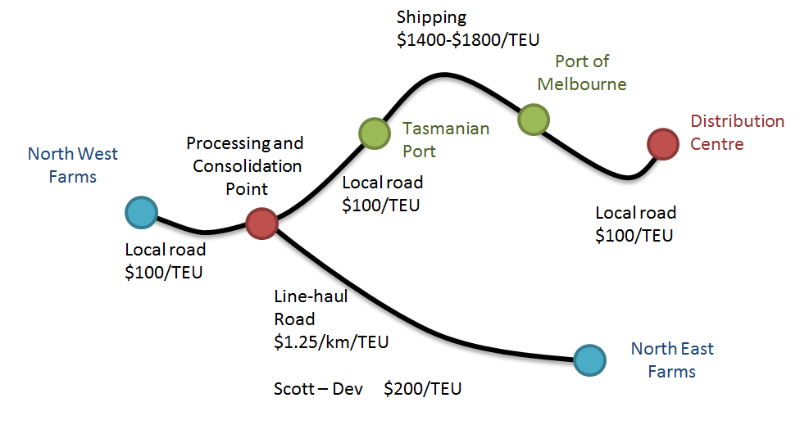

Figure 11: Fresh Supply Chain Arc Node Diagram

Prices above are indicative only, and can be higher for produce that is highly seasonal and for produce transported in less than a container load (LCL).

**SCOR Commentary**

|  |  |
| --- | --- |
|  | Fresh |
| Reliability | The Fresh supply chain relies on a ‘just-in-time system’ for produce. By definition, just-in-time systems must be reliable – otherwise the chain fails. The requirement for reliability is heightened in the Fresh supply chain as any delay in shipment would mean a loss of shelf life, which reduces the price of goods. |
| Responsiveness | The Fresh supply chain requires speed to market, and does achieve this. Many products are shipped on the day of harvest. |
| Agility | The supply chain is sufficiently agile to respond to rise and falls in orders at short notice. |
| Cost | The Fresh chain is more expensive than corresponding containerised services. TT-Line is mostly used to transport goods in this supply chain because of the faster sailing time. |
| Asset utilisation | The Fresh supply chain does not require a lot of logistics assets. Goods are transported in vans provided by freight suppliers and large storage facilities are generally not required as inventories are able to be kept low (by shipping produce the same day as it is harvested). |

Table 23: SCOR Commentary: Fresh

|  |  |
| --- | --- |
| **Observations** | For fresh supply chains, generally:   * The supply chain operates remarkably well, and can deliver product to market within 24 hours of harvesting. * Businesses are supported by the efficiency and effectiveness of this supply chain. * All three overnight freight providers offer a fresh supply chain service, resulting in some competition for volumes. * TT-Line has an advantage because of their vessel’s faster sailing capabilities and the vessels design, which allows rapid unloading for trailers. They can offer customers later drop off times and earlier delivery, which is convenient for many freight users. * Despite being relatively expensive, TT-Line ships at high utilisation levels. This suggests that although the price is high, fresh freight users value the benefits of this service. * Given the observations above, it can be said that the Fresh supply chain is well-served. |

## Low Cost – via Melbourne

Low Cost products consist of primary industry output and recycled products, which may be exported internationally. Additional costs are incurred in exporting Low Cost product to international markets (e.g. empty container relocation and international port charges).

There are Low Cost supply chains in Hobart and Bell Bay areas. The arc node diagram below illustrates a typical Low Cost supply chain based in the Bell Bay area. The supply chain includes a road haul to Burnie, shipping to Melbourne and transport to a Melbourne warehouse or to Swanston Dock for export.

Indicative charges associated with exporting product are shown below, including empty container repositioning and port charges. International sea freight charges are excluded.

.

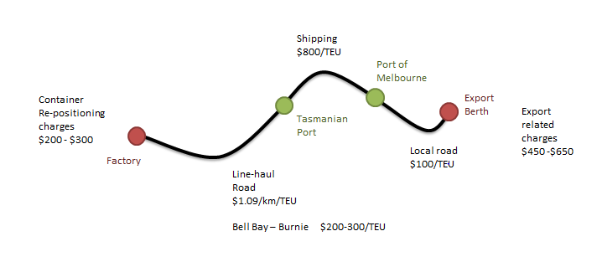

Figure 12: Low Cost Supply Chain Arc Node Diagram

**SCOR Commentary**

|  |  |
| --- | --- |
|  | Low Cost |
| Reliability | Though cost is the key, reliability is also important and this is sometimes compromised by the unavailability of export containers in Tasmania and goods being ‘bumped’ in favour of perishable goods. |
| Responsiveness | Responsiveness is not a key factor in this supply chain. Overnight services are not required, and as such this supply chain is over-served by the current Bass Strait services. |
| Agility | A high level of flexibility is not required. |
| Cost | Though cost is a concern in all supply chains, it is of high importance in the Low Cost supply chain.  The expense of re-positioning of a container, crossing Bass Strait and transhipping to the export berth gate is high. Current costs ($1,460 per TEU) are significantly higher than those incurred under a direct shipping model (around $400 per TEU).  Beyond the export berth gate, exporters incur stevedoring and other charges of around $450-$650. |
| Asset utilisation | Freight users do not require significant logistics assets. |

Table 24: SCOR Commentary: Low Cost

|  |  |
| --- | --- |
| **Observations** | For Low Cost supply chains we make the following observations:   * For exported goods   + - The availability and cost of securing empty international containers is a concern for some businesses.     - There are many steps and parties involved in the process and each step makes exporting relatively more expensive than domestic shipping. * There is a limited choice of suppliers in this supply chain. Only two Bass Strait freight providers are suitable to service this supply chain, because the TT-Line focuses on trailer freight. If rail is the chosen line-haul method, then there is only one choice of shipper as rail only connects to one RORO berth. * The nightly shipping model generally exceeds requirements – Low Cost freight users would forego service for lower prices. As it stands, freight users pay for this service but derive limited benefit. * Given the above, we conclude there is not a good match between supply chain needs and the service provided |

## Low Cost – Direct Export

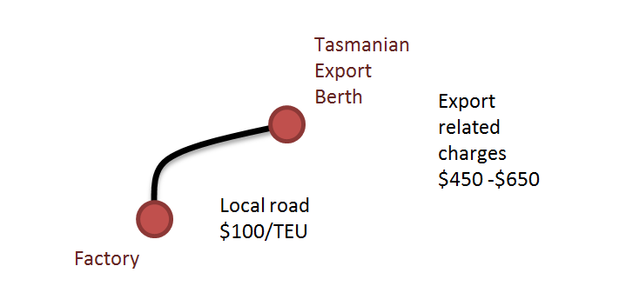The introduction of a direct international shipping service (Swire vessel) calling monthly into Bell Bay provides an alternative option for the low cost supply chain. The diagram below provides indicative costs (excluding international shipping costs) based on past Bell Bay shipping rates.

Figure 13: Low Cost Supply Chain Arc Node Diagram

|  |  |
| --- | --- |
| **Observations** | For low cost supply chains we make the following observations:   * The direct international shipping service calls monthly, and the voyage to China is 6 weeks. This may not be timely enough for all Low Cost freight users. * The cost of holding inventory for a monthly shipment may not suit all freight users. * For those freight users who have price sensitive market offers with long lead times, this supply chain would be well suited. |

## Low Inventory

Businesses in the Low Inventory supply chain ship product from Tasmania shortly after manufacture, thereby minimising the amount of inventory held Tasmania and the cost of holding that inventory. High volume shippers are prevalent in this market segment and due to their volumes able to negotiate attractive rates with freight providers. For these reasons Low Inventory supply chains also tend to be low cost.

A typical supply chain for a hypothetical large multi-national manufacturer in the Hobart area is indicated below. Truck and trains leave Hobart and travel to Burnie where containers are loaded and shipped across Bass Strait, before final transportation to a warehouse in Melbourne.

The supply chain described here is a ‘make and ship’ model. Product is made in Tasmania and moved to large mainland distribution centres, keeping both inventories and operating costs low.

Rail freight rates are unknown and we assume that for a large volume shipper, rail freight rates are equal to, if not less than, road freight rates.

The freight rates shown below are indicative.

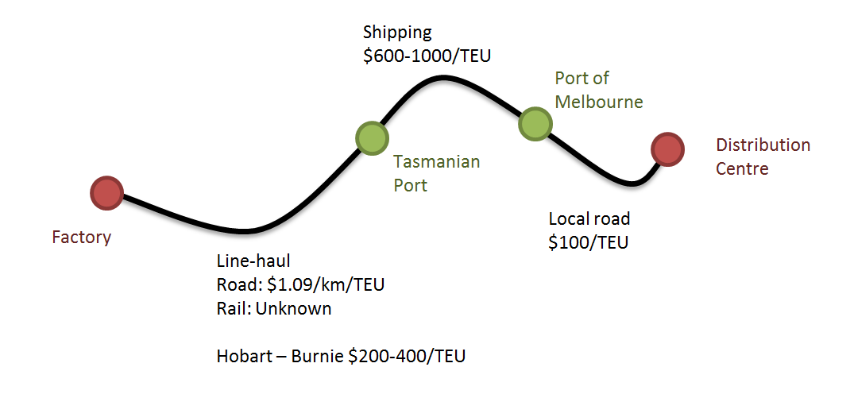

Figure 14: Low Inventory Supply Chain Arc Node Diagram

**SCOR Commentary**

|  |  |
| --- | --- |
|  | Low Inventory |
| Reliability | Reliability is important for this chain. Although goods do not need to reach a consumer location ‘just in time’, it is important that goods are moved away from manufacturing facilities in a timely manner. |
| Responsiveness | Goods need to be transported efficiently. Speed through the chain is not essential. |
| Agility | Agility is generally not required as goods are the output of continuous industrial processes and therefore volumes are predictable. For some businesses, there are Christmas demand peaks which must be met. |
| Cost | Daily services to distribution centres in Melbourne enable business to reduce the cost of warehousing in Tasmania. As a result warehouses can either be smaller in Tasmania, or not operated at all. |
| Asset utilisation | Companies within this supply chain require minimal assets. There are fewer physical assets and less working capital. |

Table 25: SCOR Commentary: Low Inventory

|  |  |
| --- | --- |
| **Observations** | * All three overnight freight providers are able to provide a service, resulting in some competition for this work. * The provision of overnight services enables inventory to be moved through the supply chain quickly, reducing Tasmanian businesses’ holding costs and potentially providing a benefit to their customers. * Though businesses make use of overnight shipping services, they do not necessarily require it. Some businesses indicated a less frequent service would be acceptable to them, if it was accompanied with a suitable reduction in the freight rate. * Overall there is a good match between supply chain needs and the service provided. |

## Perishable

The Perishable supply chain consists of products with a defined shelf life, but are not as time sensitive as fresh food, such as vegetables or dairy.

A typical supply chain for a perishable product is illustrated below. Output is typically consolidated in a production or packing plant and transported to the port in refrigerated containers to be shipped to Melbourne. Product is then transported to a distribution centre or transhipped to Swanson Dock for international export.

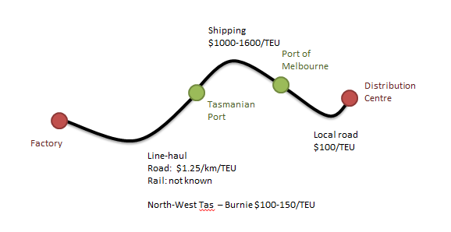

Figure 15: Perishable Supply Chain Arc Node Diagram

**SCOR Commentary**

|  |  |
| --- | --- |
|  | Perishable |
| Reliability | This is a ‘just-in-time’ supply chain, and must be reliable. The supply chain is well served by current service providers. Daily sailings leave on time. |
| Responsiveness | This supply chain requires speed to market, however the need is not as urgent as with the Fresh supply chain. The freight industry in Tasmania is highly capable in this area. |
| Agility | The daily service and vertically integrated structure of supply chains in Tasmania provides flexibility. |
| Cost | Users of the Perishable supply chain report that costs are too high. |
| Asset utilisation | Assets are well utilised but specialised containers (reefers) are sometimes in short supply. |

Table 26: SCOR Commentary: Perishable

|  |  |
| --- | --- |
| **Observations** | * All three overnight freight providers are able to provide a service. As a result there is some competition for this work. * The provision of overnight services enables inventories to be moved on through the supply chain quickly, reducing holding costs and potentially offering benefit to customers. * There is a good match between supply chain needs and the service provided. |

## Empty Containers

There is a large flow of empty containers across Bass Strait, and the costs of sourcing a container from Melbourne are significant for freight users.

The distance from Melbourne to Hobart is 733km. On the mainland, the cost of transporting a container that distance would be $700-$800, though an empty would attract a lower rate.

In Tasmania the cost is lower ($400-$600), as illustrated by the diagram below.

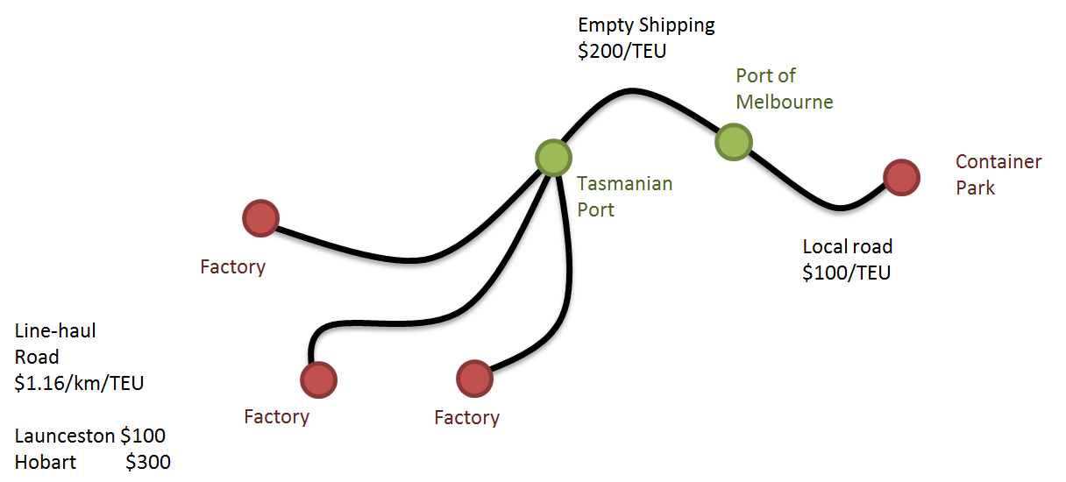

Figure 16: Empty Containers Supply Chain Arc Node Diagram

|  |  |
| --- | --- |
| **Observations** | * Although there are many empty containers in the system it can be difficult to source the right kind. |

# Review of Tasmanian Supply Chain Costs

In addition to understanding the quality and efficiency of Tasmanian supply chains, Aurecon were engaged to investigate the cost of supply chains in Tasmania and benchmark these costs against other markets.

The following review of Tasmanian supply chain costs provides indicative freight rates for road transport and shipping across Bass Strait. Indicative rates for rail transport are classified commercial in confidence, and are not provided for this reason.

In addition to linehaul and shipping costs, freight users incur other expenses such as handling charges and storage. The estimated cost of repositioning an empty container from Melbourne to Tasmania is approximately $400 to $600, depending on the final destination. This review compares the total cost for a typical Tasmanian supply chain to a similar supply chain on the mainland.

For road freight, approximately 23% of vehicle costs are fixed and the remaining 77% vary with the volume of work. By comparison, approximately 65% of sea freight costs are fixed (including capital, wages and maintenance) and the remaining 35% of cost is variable or related to volume and activity[3].

Analysis shows that road freight rates in Tasmania are competitive and comparable to mainland rates. While the cost of shipping goods across Bass Strait is a major concern to freight users, the analysis shows that Bass Strait wharf-to-wharf gate prices vary markedly. Prices for low volume shipments range from $1,000 to $1,200 per 20ft dry TEU, while for high volume freight users prices can be half of this.

Shipping rates to transport containers across Bass Strait include port charges (both in Tasmania and at the Port of Melbourne). Additional charges such as quarantine and marine insurance may apply to international exports. These types of charges (which typically amount to $450 - $650) should be disaggregated when making comparisons between shipping services.

A discussion of factors that influence the cost of shipping is included in Aurecon’s accompanying report ‘Tasmanian Shipping and Ports’. When wharf-to-wharf costs are converted to a ‘per TEU per km’ rate, the cost is approximately two to three times more expensive than a typical road freight rate. However, for shippers eligible for the Tasmanian Freight Equalisation Scheme (TFES), shipping rates align more closely with road freight rates.

## Road Freight Services and Rates

The majority of Tasmania’s container freight is carried on road. The road freight task is serviced by a number of transport providers.

Road freight rates in Tasmania are competitive and comparable to mainland rates.

|  |  |
| --- | --- |
| **Common Vehicles** | * Small and medium rigid vehicles * 19m Semi-Trailers * 13.7m Refrigerated (Pantechnicon) * 26m B-Doubles |
| **Vehicle Costs** | * Labour (Wages and on-costs) * Fuel * Tyres * Maintenance * Capital investment and interest * Insurance * Registration   Typically 23% of costs are fixed and 77% vary with the volume of work |
| **Rates** | Road freight operating costs for a range of vehicles have been identified through industry research. These rates are reported below.   |  |  |  | | --- | --- | --- | | Vehicle | Unit | Rate | | 19m Semi – Shorthaul | Per hour | $130 | | 19m Semi – Linehaul | Per km | $2.17 | | 13.7m Refrigerated – linehaul | Per km | $2.50 | | 26m B-Double – linehaul | Per km | $2.31 |   Table 27: Indicative Road Freight Operating Costs by vehicle type |

|  |  |  |  |  |  |  |  |  |  |  |  |  |  |  |  |  |  |
| --- | --- | --- | --- | --- | --- | --- | --- | --- | --- | --- | --- | --- | --- | --- | --- | --- | --- |
| **Variation in Road Rates** | The cost to transport each container can vary significantly with the utilisation of the vehicle. For example, an exporter with a heavy product may load 20 foot containers at approximately 27 tonnes. However, the gross mass limit for a tri axle truck is 42.5 tonnes, meaning that only one container can be loaded on each truck without exceeding the gross mass limit.  The table below outlines transport costs for different levels of vehicle utilisation.   |  |  |  |  | | --- | --- | --- | --- | | Truck Utilisation | 1 TEU | 2 TEU | 3 TEU | | 19m Semi-Trailer | $2.17 per TEU/km | $1.09 per TEU/km | N/A | | 13.7m Refrigerated – linehaul | $2.50 Per TEU/km | $1.25 per TEU/km | NA | | 26m B-Double | $2.31 per TEU/km | $1.16 per TEU/km | $0.77 per TEU/km |   Table 28: Standard Tasmania Truck Haulage Cost Rates |

## Rail Freight Services and Rates

TasRail is Tasmania’s sole provider of rail transport and operates on a commercial basis. Rail freight rates are commercial in confidence and therefore are not considered in this study.

Anecdotally, rail is considered competitive with road freight over long distances and is most suitable for hauling bulk commodities. Rail is least suitable for time sensitive retail tasks where flexibility is required.

In Tasmania, bulk and containerised heavy commodities represent the greatest share of rail freight.

Where freight is contestable to road or rail, it can be assumed that the inherent inflexibility of rail means rail freight rates need to be lower than road freight costs despite the broader benefits of rail (e.g. reduced congestion and emissions) to attract patronage.

## Sea Freight Services and Rates

TT-Line, SeaRoad Shipping and Toll-ANL are the major providers of Bass Strait shipping services. They all provide overnight shipping services (more detail is included in the accompanying ‘Tasmanian Shipping and Ports’ report), enabling freight users to reach markets quickly. A ‘just in time’ service enables shippers to deliver containers or trailers to terminals by early or late afternoon on any weekday to be shipped to Melbourne overnight and arrive at the end distribution point (a distribution centre, market or factory) the next day.

The ability to access a ‘just in time’ service is important to businesses in the food and agricultural products sector, particularly for those businesses that deal with fresh and refrigerated seafood and market produce. TT-Line is considered to have the best service for fresh freight, as it sails last, arrives earliest and can unload trailers very quickly.

The retail sector is the largest part of the inbound freight task, and prefers to hold low levels inventory and to move freight quickly. Inbound retail freight is arguably the main driver for the overnight service. For outbound freight, just over half relies on the “make and ship” business model, sending freight out of Tasmania within a day of harvest or manufacture. As with the inbound freight task model, the outbound freight task is also a significant driver for the overnight shipping service.

The two largest shippers across Bass Strait are vertically integrated companies, and provide road freight and freight forwarding services. This benefits freight users by having services managed by one party, and can reduce points of failure in the supply chain, making it more reliable. However, the downside to his is that there is a lack of choice for competing freight forwarders who believe the integrated shipping provider can be conflicted in providing their service.

The services provided by the various freight operators are:

|  |  |  |  |  |  |  |  |
| --- | --- | --- | --- | --- | --- | --- | --- |
| Service | Toll | SeaRoad | TT-Line | SRT | Fresh Freight | TasFreight | TasRail |
| Mainland transport | x |  |  | x |  |  |  |
| Shipping | x | x | x |  |  |  |  |
| Road/rail Transport | x | x |  | x | x | x | x |
| Freight Forwarding | x | x |  | x | x | x |  |

Table 29: Services Provided by Major Transport and Logistics Suppliers in Tasmania

### Indicative Shipping Rates

Shipping rates are typically quoted on a wharf gate-to-wharf gate basis. That is, the price is inclusive of all the individual components, such as lift-on / lift-off and port charges.

As a premium freight service carrying largely refrigerated fresh food, TT-Line has a different price structure compared to Toll-ANL and SeaRoad Shipping. Consultation with numerous freight users indicates TT-Line has a price of approximately $225 per linear metre including loading and unloading of trailers.

Prices ascertained through consultation with freight users are shown below. Prices are indicative only, as many freight users provided data in a veiled fashion, and prices vary depending on annual volume.

|  |  |  |  |
| --- | --- | --- | --- |
| Container | High Volume | Medium Volume | Low Volume |
| 20’ Container | $600 - $800 | $800 - $1,000 | $1,000 - $1,200 |
| 20’ Reefer equivalent (includes refrigerated trailers) | <$1,000 | $1,000 – $1,400 | $1,400 - $1,800 |

Table 30: Indicative Sea Freight Rates

Freight costs per TEU per kilometre have been calculated for a series of price points, based on a Bass Strait crossing distance of 420 km. The summary of these costs are shown in the table below.

|  |  |  |  |
| --- | --- | --- | --- |
| Wharf to Wharf Cost | Rate per TEU/km  Before TFES | Out-of-Pocket Cost if TFES is Applicable | Rate per TEU/km After TFES |
| $1,600 | $3.81 per TEU/km | $745 | $1.77 per TEU/km |
| $1,400 | $3.33 per TEU/km | $545 | $1.30 per TEU/km |
| $1,200 | $2.85 per TEU/km | $389 | $0.92 per TEU/km |
| $1,000 | $2.38 per TEU/km | $289 | $0.69 per TEU/km |
| $800 | $1.90 per TEU/km | $227 | $0.54 per TEU/km |
| $600 | $1.43 per TEU/km | $181 | $0.43 per TEU/km |

Table 31: Notional TEU Rates

A review of wharf to wharf costs for Bass Strait shipping indicates that on a per TEU per km basis, the cost is approximately two to three times more expensive than typical road freight rates ($1.09 per TEU/km). However, for shippers receiving TFES assistance, shipping rates compare favourably with road freight rates. For example, a shipper who pays a wharf to wharf cost of $1,000 and receives the TFES assistance will pay $0.69 per TEU/km.

### Volume Variation in Shipping Rates

The volume of units shipped has a significant impact on price, with high volume Bass Strait shippers paying less per TEU than their low volume counterparts. Seasonality and container equipment requirements also impacts pricing, with shippers with consistent volumes receiving lower rates than highly seasonal shippers. The relationship between volume and price is shown below.

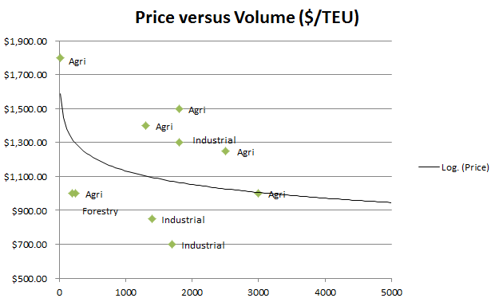

Figure 17: TEU Shipping Price vs. Quantity

### Empty Container Positioning Costs

Empty containers represent 31% of inbound containers and 33% of outbound containers. Empty container repositioning is required due to a range of factors, including:

* A mismatch in container types – for example 40ft international containers enter Tasmania while 20ft international containers leave.
* An imbalance in import/export trade with more full containers entering Tasmania than leaving.

Stakeholder discussions indicate that the repositioning of empty containers is a significant issue facing export freight users. Notwithstanding the physical challenge of obtaining an empty export container and securing passage across Bass Strait, this task attracts a repositioning cost.

The cost to reposition an empty container from Melbourne to Tasmania is approximately $400-$600 depending on the final destination and typically includes Bass Strait shipping and road transport costs. Container hire is typically only charged after the seventh day.

|  |  |  |  |  |
| --- | --- | --- | --- | --- |
| Empty Container Reposition | Mainland Costs | Cost – Bass Strait | Cost – Land Transport | Total Cost |
| Melbourne to Launceston | $100 | $200 | $100 | $400 |
| Melbourne to Hobart | $100 | $200 | $300 | $600 |

Table 32: Indicative Empty Container Positioning Costs

Empty container positioning is not generally of concern to domestic freight users, as domestic containers are in surplus by a large amount in Tasmania. For some freight users, containers are included by the freight supplier (e.g. Toll) and included in freight rates.

## Port Costs

Shipping rates to transport containers between Tasmania and Melbourne include the TasPorts and Port of Melbourne port charges, including Webb dock lift-on/lift-off costs. Export freight users face additional port charges to tranship goods via Melbourne, and dependent on the goods may include charges such as:

* Container consumption
* Quarantine
* Health certificates
* Container lining
* Marine Insurance

Typical charges and indicative rates for export shippers are:

|  |  |
| --- | --- |
| Charge | Indicative Rate |
| Terminal Handling Charge (THC) | $200 - $300 |
| Basic Service Rate Additional (BSRA) | $150 - $200 |
| Security | $20 |
| Bill of Lading | $60 - $100 |
| Manifest | $25 |
| Total | $450 - $650 |

Table 33: Indicative Charges and Rates Applied To Exports

These additional charges are sometimes included in freight user’s representations of Bass Strait shipping charges. To ensure costs are not misrepresented, it is important to disaggregate these charges before making comparisons between Bass Strait and other shipping services.

## Tasmanian Freight Equalisation Scheme

### Structure

The Tasmanian Freight Equalisation Scheme (TFES) was originally introduced in July 1976. The Government’s objective was to alleviate the freight cost disadvantage incurred by shippers of eligible non-bulk goods moved by sea between Tasmania and the mainland.

Under the TFES, a shipper’s wharf-to-wharf freight bill from northern Tasmania to Victoria minus the Road Freight Equivalent cost, determines how much assistance an individual shipper may be paid (the ‘sea freight disadvantage’). This is calculated before adjustments are made for the heavy freight discount and Scheme incentive structure (the Scheme incentive structure means that shippers with higher freight costs are not paid the full ‘sea freight disadvantage’ – the maximum TFES payment is capped at $755 per TEU plus an intermodal allowance of $100).

Where claims are not submitted on a wharf-to-wharf basis, the freight bill is adjusted by subtracting a fixed amount per TEU equivalent for each door-to-wharf or wharf-to-door movement to estimate the notional wharf-to-wharf equivalent freight bill.

The key benchmark underpinning the TFES calculation of shippers’ sea freight disadvantage is the ‘road freight equivalent’ – the notional cost of transporting the same amount of freight 420 kilometres by road on the mainland.

Where claims are made on a door-to-door basis, the freight bill is converted to a wharf-to-wharf basis by subtracting fixed parameters. The current parameters are $230 per TEU which equates to $460 for a door-to-door shipment.

Figure 18: Structure of TFES

**door**

**door-to-wharf**

**intermodal cost**

**wharf-to-wharf cost**

**door**

**wharf**

**wharf**

**intermodal cost**

**door-to-wharf**

**Bass Strait (420 km, Northern Tasmania to Port of Melbourne)**

**Sea journey**

**Origin**

local collection

**highway start**

road transport - linehaul

**road freight Equivalent (420 km)**

**Road journey**

**Destination**

local delivery

**highway end**

*Source: BITRE based on TFES Review Authority (1998) and Ministerial directions (DITRDLG 2008)*

The actual assistance payable under TFES is:

* the shipper’s calculated sea freight cost disadvantage; less
* an adjustment – to provide an incentive to minimise freight rates; plus
* the fixed allowance for intermodal costs.

In 1998 the TFES review authority recommended that the assistance payable to a shipper incorporate an adjustment to incentivise shippers to minimise freight rates. This relates to the upper limit of TFES assistance of $855 per TEU (including the intermodal allowance). This upper limit applies for a notional wharf to wharf disadvantage of greater than or equal to $1,007 per TEU.

The Ministerial Directions (2008) identifies four classes of freight users. These classes receive a proportion of the notional wharf-to-wharf freight cost disadvantage which declines as the cost increases:

* 100 % of the first $335.50 per TEU (Class 1 shipper); plus
* 75 % for the second $335.50 per TEU (Class 2 shipper); plus
* 50 % for the third $335.50 per TEU (Class 3 shipper); plus
* Nil for amounts above $1006.50 per TEU (Class 4 shipper).

It is important to note that a Class 1 freight user with a notional wharf-to-wharf disadvantage of $0 to $335.50, which equates to a notional wharf-to-wharf cost of $281 to $616.5 incurs the same out of pocket expense of approximately $181 regardless of whether their notional wharf-to-wharf cost is $281 or $616.50.

|  |  |  |  |  |  |
| --- | --- | --- | --- | --- | --- |
| Shipper | Notional Wharf-to-Wharf rate | Road Freight Equivalent | Notional Wharf-to-Wharf Disadvantage | TFES Payment | Out of Pocket Expense |
| Class 1 | $281 to $616.50 | $281 | $0 to $335.50 | $0 to $435.50 | $181 |
| Class 2 | $616.51 to $952 | $281 | $335.51 to $671 | $435.51 to $687.13 | $181 to $264.88 |
| Class 3 | $952.01 to $1,287. 50 | $281 | $671.01 to $1,006.50 | $687.13 to $854.88 | $264.88 to $432.63 |
| Class 4 | >$1,287.51 | $281 | >$1,006.51 | $854.88 | >$432.64 |

Table 34: A Comparison of Out of Pocket Expenses for Shippers Eligible for TFES

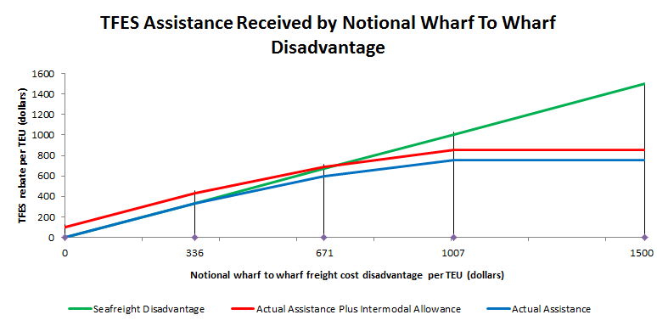

Figure 19: Tasmania Freight Equalisation Scheme Assistance

### TFES and Exports

There are eligibility requirements that freight users must meet to receive TFES assistance, which are set out in the Ministerial Direction – Guidelines (MDG).

Goods eligible for southbound assistance are generally related to primary industries, such as agriculture, forestry, fishing, manufacturing and mining.

TFES payments do not extend to exports unless they undergo a manufacturing or value adding process on the mainland prior to export as per the MDG. Also, not all goods moving in and out of Tasmania in the domestic market are eligible for assistance.

The TFES does not apply to goods that are:

* shipped as air cargo, except in special circumstances;
* shipped as bulk cargo; or
* intended to be shipped out of Australia, unless they undergo a manufacturing process on the mainland prior to export.

An export freight user incurs the total cost of the notional wharf-to-wharf rate. To highlight the difference in costs incurred by exporters and TFES eligible domestic freight users - an export with a notional wharf-to-wharf rate of $1,287.51 incurs the entire amount as an out of pocket expense, compared to a TFES eligible domestic freight user shipping between northern Tasmania and Victoria who incurs an out of pocket expense of $432.64.

The structure of the TFES can produce a scenario where businesses in export markets may consider relocating processing activities to the mainland to reduce transport costs, at a cost to Tasmanian employment. For example, fruit or vegetables may be prepared and packaged for supermarkets and transported across the Bass Strait in bulk. In this scenario businesses may consider relocating processing activities to the mainland in order to be eligible for TFES assistance. Stakeholder feedback indicates that a number of businesses are considering migrating value adding activities to the mainland.

## Medium Volume Shipper Breakdown of Prices

A number of different tariffs apply to Bass Strait shipping services, with each customer having their own rate card, comprising of multiple fees. Rate cards are developed through commercial negotiation and it may be the case that similar businesses face different freight rates.

Indicative freight rates have been developed based on information gained through interviewing freight users.

The chart below compares costs incurred by a medium volume domestic shipper (before TFES) and a medium volume overseas shipper. The Bass Strait shipping cost is based on is the mid-point of the range of estimated charges medium volume shippers face - $1,000/TEU.

As information on charges has not been made available it is not possible to break down shipping cost into its components. As such, charges include lift on/lift off allowances and all port charges. Although port charges are published, Bass Strait shippers have negotiated commercially confidential rates with TasPorts and the Port of Melbourne which vary from the published schedules.

As a rule of thumb the fixed/variable split of costs for ships is 65%:35%, and the lift on/lift off charge is approximately $50. These costs are shown below.

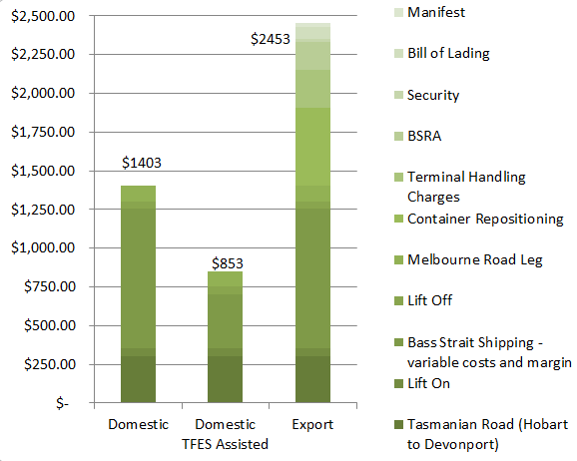

Figure 20: Breakdown of Transport Costs

There is a common view among stakeholders that Bass Strait shipping costs are high. This is true in comparison to road freight in mainland states; though the TFES reduces this burden for eligible shippers. However, direct exporters are ineligible for the TFES, and receive no relief from Bass Strait shipping costs.

In addition to the usual freight costs, other charges, such as empty container repositioning adds to costs incurred by domestic shippers. These additional costs amount to around $500, although large exporters may be able to negotiate cheaper Bass Strait shipping costs.

Total export shipping costs are up to $1,600 per TEU more expensive than a domestic shipper’s cost to ship goods from Tasmania to Melbourne.

## Export

The cessation of the direct call international shipping service to Bell Bay and the impact on exporters is well documented. The following observation compares the cost impact for an exporter who previously shipped from Bell Bay with the AAA service to an exporter who now tranships through Melbourne.

|  |  |
| --- | --- |
| **Two Cases** | * Launceston to Bell Bay (47km – 35min travel time); and * Launceston to Port of Melbourne (via Bass Strait). |
| **Assumptions** | * Cost to relocate empty container from Bell Bay to Launceston - $300. * Launceston to Bell Bay road freight - $100. * Bass Strait shipping cost $1000 (wharf to wharf). * Transhipment cost - $100 based on hourly semi-trailer rate. |
| **Cost Breakdown** | Table 35: Comparative Transport Cost Breakdown  Note: The assumed Bass Strait cost of $1,000 is regarded as competitive. Based on the scenario above, the impact to an exporter is $1,260 per TEI. This assessment does not include the price of international ocean freight which varies depending on carrier. |

## Cost Benchmarking

A key focus of this study is to benchmark the cost of transporting a container originating in Tasmania against a road journey originating on the mainland.

Aurecon’s ‘Tasmanian Shipping and Ports’ Report provides details of cost benchmarking Bass Strait shipping cost against comparable international journeys. This benchmarking exercise found that the nominal rack rate of Bass Strait prices appear to be higher by 24% on average, however this price difference should be considered in context. It is influenced by higher Australian costs for labour and bunker fuel prices, which are around 23% higher than European costs.

The challenge of any benchmarking exercise is to find a suitable and realistic comparison as different freight tasks have different drivers. An example of these drivers is the preference to use TT-Line for fresh food based on the faster sailing time compared to other services which may be less cost.

The following benchmarking exercise compares the cost of transporting a container (1 TEU) from Hobart to Melbourne (733km) against the cost of transporting a container a similar distance on land only.

A land journey between Adelaide and Melbourne is used to demonstrate road costs, as the distance is close to the distance between Hobart and Melbourne.

|  |  |
| --- | --- |
| **Four scenarios** | * Hobart to Melbourne (via Devonport) for a container. * Hobart to Melbourne (via Devonport) for domestic container (TFES assisted). * A hypothetical journey (733km) on a 19m Semi undertaken on land only. * A hypothetical journey (733km) on a 26m B-Double undertaken on land only. |
| **Assumptions** | * A Semi-trailer operates at a cost of $2.15/km ($1.09/km/TEU). * A B-Double operates at a cost of $2.30/km ($0.77/km/ TEU). * A nominal wharf-to-wharf cost of $1,000 (includes intermodal lift on/off costs of $100). * A nominal cost between Webb Dock and the final destination in Melbourne of $100. |

|  |  |  |  |  |  |  |  |  |
| --- | --- | --- | --- | --- | --- | --- | --- | --- |
|  | Export – Hobart to Melbourne | | Domestic (TFES assisted) – Hobart to Melbourne | | Land only – 19m Semi – 733km | | Land only – 26m  B-Double – 733 km | |
| Unit | Cost | Unit | Cost | Unit | Cost | Unit | Cost |
| Road Leg | 278km at $1.09/km | $303 | 278km at $1.09/km | $303 | 733km at $1.09/km | $799 | 733km at $0.77/km | $564 |
| Lift On |  | $50 |  | $0 |  | - |  | - |
| Bass Strait | Devonport – Melbourne | $900 | Devonport – Melbourne (TFES assisted) | $450 |  | - |  | - |
| Lift Off |  | $50 |  | $0 |  | - |  | - |
| Further Road Leg |  | $100 |  | $100 |  | - |  | - |
| TOTAL |  | $1403 |  | $853 |  | $799 |  | $564 |

Table 36: Cost Benchmarking Comparing Transport Costs for 1 TEU between Hobart and Melbourne to Costs for 1 TEU between Adelaide and Melbourne

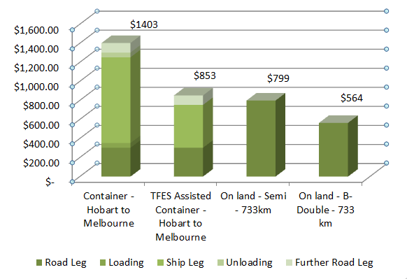**Figure 21: Comparative Transport Cost Breakdown**

As indicated in the table and chart above, the cost to transport a container from Hobart to Melbourne ($1,403) is almost double the cost to transport a container the same distance on land by semi-trailer ($799). These costs do not include additional costs incurred by freight users in Tasmania such as empty container relocation, cleaning, fumigation and inspection.

The cost to move a container from Hobart to Melbourne is reduced by $550 to a total cost of $853 where the exporter is eligible for TFES assistance. A journey of the same distance undertaken on land varies from $564 to $799 based on standard rates for a 19m Semi-trailer (2 TEU) and a 26m B-Double (3 TEU) vehicle.

**Road freight pricing**

Tasmanian road freight prices have also been compared against mainland and New Zealand rates. The analysis below considers a container originating on the North Island of New Zealand, crossing the Cook Strait to the South Island.

|  |  |
| --- | --- |
| **Assumptions** | * Rates have been calculated for a dry container on a dollar per kilometre per TEU rate. * 19m semi-trailer (or equivalent) vehicle is used. * TEU rates are calculated on the assumption that the truck is fully utilised i.e. two paying TEU’s per truck. |

The figure below illustrates comparative road freight prices.

Tasmania Victoria New Zealand

Figure 22: Comparative Road Freight Price

|  |  |
| --- | --- |
| **Rate Comparison** | **Victoria**  Tasmanian rates are broadly comparable to Victoria. The price data above indicates that Tasmania is marginally more expensive than Victoria. The reason for this is likely to be that fuel costs are higher in Tasmania than mainland state capitals.  **New Zealand**  Road freight prices are notably higher in New Zealand than Tasmania. While labour costs are higher in Australia, New Zealand freight users pay road user charges that do not apply in Australia. |

# Findings

## Supply Chains

Tasmanian supply chains are simple, and largely similar across different commodity groups. The linehaul nature of supply chains supports the ‘make and ship’ business model used by many Tasmanian freight users. This differs from mainland supply chains, which involve both linehaul and distribution. Many industries in Tasmania do not have a distribution function in the State, as this step takes place on the mainland.

Overall, there are few opportunities for improvement for the linehaul function. Considering a commodity or business in isolation, once a product is placed on a truck there is little that can be improved. There are, however, opportunities for improvement to be found outside individual commodity supply chains and individual businesses. The opportunities for improvement in Tasmania are to consider how these supply chains work together, how freight is planned and whether or not the network can be improved.

## Innovation

A common feature of the logistics industry is the constant search for efficiencies. Through the interview process, Aurecon discovered a number of efficiencies introduced by companies in Tasmania, and these are detailed below.

An observation we made was that where excellence occurs, it is generally confined to a single company and these ideas and efficiencies do not flow to others. Larger companies tend to have more efficient supply chains because they have the resources to investigate problems and invest in their remedies.

|  |  |  |
| --- | --- | --- |
| Company | Innovation | Comment |
| Cadbury | Slip sheets | Removes the need for a pallet, allows more to be packed into a container |
| Petuna | Trailers on barges | Can pump fish directly to road trailer eliminating a double handling step |
| Websters | Fantainer – door ajar shipping | Onions arrive in good condition |
| Norske | Skate loading of containers | Removes the need for a pallet, allows more to be packed into a container |
| Toll | Specialised reefers | Separates reefer from refrigeration plant, allowing more to be stored in container |
| Cadbury, Norske | Melbourne warehousing | Reduces inventory holdings and warehousing costs |

## Efficiencies

The efficiency of many Tasmanian supply chains is evident – for example, it is not uncommon for produce to be moved from field to market within 24-36 hours.

Inefficiencies arise at the nodes (transfer points) in a supply chain. In point to point supply chains such as Tasmania’s freight system there are few nodes except for the endpoints.

## Inefficiencies

Some inefficiency was noted, which were mostly the result of flaws in the design or execution of the supply chain.

|  |  |
| --- | --- |
| Comment | Observation |
| Intermodal rail | On the mainland it is inefficient to use rail over short distances such as those in Tasmania. For freight already loaded onto a truck, it is not clear that the cost and delay of changing modes is worthwhile. |
| Driving past two ports | For export freight that originates from Bell Bay it is inefficient (but unavoidable) to pass two ports (Bell Bay and Devonport) on the way to the Port of Burnie. |
| Container availability | The unavailability of certain container types is a shortcoming of the system. Some manufacturers add to their lead times to cater for delays in securing containers. Container availability may be impacted by shipping capacity levels. |
| Goods left behind | At peak times, some goods are left behind in favour of perishable freight. |
| Excess empty containers | See below |

Table 37: Supply Chain Inefficiencies

## Excess Empty Containers

Empty containers account for more than 27% of the Bass Strait shipping task. For a system constrained by capacity, this is a waste.

|  |  |  |  |  |  |
| --- | --- | --- | --- | --- | --- |
| Direction | 20 ft | 40 ft | All Containers | Wheeled | All Unitised |
| Entering Tas | 27,016 | 5,690 | 38,396 | 4,403 | 47,202 |
| Leaving Tas | 47,706 | 5,023 | 57,752 | 8,208 | 74,168 |
|  | 74,722 | 10,713 | 96,148 | 12,611 | 121,370 |

Table 38: Empty Containers

The reasons behind the large volume of empty containers being shipped are not clearly known, but the following factors may impact volumes:

* A mismatch between inbound (domestic) and outbound (international) containers.
* A mismatch between container sizes 40ft vs 20ft.
* An absence of coordination between shippers.
* Poor planning.

## Freight Service

Most freight users regard the freight service across Bass Strait as very good, because it is:

* Provided by multiple shippers – provides for a level of redundancy.
* Nightly – 6 to 7 days per week – can ship fresh freight.
* Reliable – for most users it is possible to ship with a high degree of certainty.
* Efficient – ships unload in a matter of hours.
* Timely – shipping at the end of the day meshes well with work day in Tasmania.

Businesses have developed their supply chains around the reliability, timeliness and daily schedule of shipping services.

These shipping services are a one size fits all model, and some freight needs this service, some freight takes advantage of this service and some freight pays for this service level but derives no benefit.

Only a small proportion of freight (15%) strictly requires this level of service. This is fresh freight, which needs to get to market quickly to maximise shelf life (and in turn price).

Around half of freight (51%) across Bass Strait can make use of this service and does, for example, fresh freight.

Some freight users reported reliability problems. They were that:

* at peak times their freight is left behind in favour of perishable freight; and/or
* export containers were often hard to obtain.

On balance the freight service meets the needs of most users, with harvest time presenting a challenge to most freight users.

## Shipping Capacity

Daily Bass Strait shipping capacity in one direction is around 860 TEU. Based on a six and seven day shipping schedule, monthly capacity is around 23,000 TEU. Average utilisation is 80%, with an average of 18,500 TEU moved monthly each way in FY 2011/12.

Logistics systems are commonly considered “at capacity” at 85% utilisation. This is a level that permits recovery should some complication occur (e.g. a spike in demand or unexpected outage).

In peak months utilisation can reach over 90% for the month. Weekly peaks push utilisation rates even higher, resulting in service concerns during peak season. To meet the increased demand, Toll increases their sailing schedule to provide a service 7 days per week, and TT-Line operates daylight sailings.

## Freight Costs

As in any market, a range of factors influence freight pricing. Volume appears to be a major influence on freight prices across the Bass Strait.

It is important to acknowledge that freight prices are negotiated on a commercial basis and the price for similar commodities can vary. Based on industry interviews, the following prices have been inferred for shipping a TEU (dry) across the Bass Strait:

|  |  |  |  |
| --- | --- | --- | --- |
|  | Volume (TEU/yr) | Bass Strait Shipping** Rate ($/TEU) | Bass Strait Shipping ($/TEU/km) |
| High volume shipper | >1000 | $600-$800 | $1.43 - $1.90 |
| Medium volume shipper | 100 | $800-$1,000 | $1.90 - $2.38 |
| Low volume shipper | 10 | $1,000-$1,200 | $2.38 - $2.86 |
| **Wharf gate to wharf gate pricing | | | |

Table 39: Bass Strait Crossing Rate

Most freight users regard Bass Strait shipping costs as expensive; however this is not necessarily the case for all shippers.

A comparison of Tasmanian road freight costs and mainland road freight costs indicates they are on par (ranging from $1.09 to 1.16./TEU/km).

On a $/TEU/km basis, sea freight is two to three times more expensive than road freight. For a freight user receiving TFES assistance, costs for shipping between northern Tasmania and Victoria sea freight costs are brought at least in line with mainland road freight costs, if not better.

|  |  |
| --- | --- |
|  | Rate ($/TEU/km) |
| Road freight | $1.09 - $1.16 |
| Sea freight (Medium volume shipper) | $1.90 - $2.38 |
| Sea freight after TFES (Medium volume shipper) | $0.54 - $0.69 |

Table 40: Bass Strait Freight Costs

## Export Freight Costs

Tasmanian exporters face high costs compared to Tasmanian domestic shippers. Exporters have a longer supply chain and often need to reposition empty containers, adding to their costs. The repositioning of containers for domestic shippers appears to be built into freight costs.

Analysis indicates that a low to medium volume shipper would pay $1,403 (or $853 if eligible for TFES) to ship a dry TEU from Tasmania to Melbourne. An exporter would pay $2453 (including the cost of placing product on an export vessel), assuming the same costs to cross Bass Strait.

## Data Availability

Aurecon found there was limited reliable and reportable data on freight volumes, type and cost in the public domain. Some companies and organisations are at critical points in the supply chain and can collect this data for themselves, but it is not available generally.

The absence of data can hamstring planning for the sector; it can also be a barrier to more value adding developments for the sector. Many advances in logistics, such as the routing and tracking of vehicles, are built on data which is increasingly available and collected real time.

The Hunter Valley Coal Chain Coordinator is an outstanding example of the value being achieved through the pooling of information from different industry participants for the benefit of all involved in the industry.

## Market Structure

There is a tendency for industries in Australia to develop such that there are one or two large players and then several small participants. This is generally a good thing as the large players, being large invest in advances that benefit their customers. The banks and supermarkets would be examples of this.

The freight market in Tasmania similarly has some strong players and similarly consumers are well served, with frequent service and access to good information systems. In the course of this study Aurecon received comment that consumers of freight would like to see a wider choice of freight providers. Limited choice is in part the difficulty of small economies.



# Opportunities for Improvement

## Capacity Expansion for Shipping

Given shipping is near (and sometimes exceeds) capacity limits; an increase in shipping capacity is required. Potential considerations include:

* Existing 6 days per week operators to extend to 7 days per week operations.
* Encouraging existing shippers to invest in larger vessels or additional vessels.
* Improved planning systems to reduce impact of seasonal peak.
* Reducing the number of empty containers being shipped.

## Shipping from Bell Bay

A substantial market for freight is based around Bell Bay. This freight does not require a daily service but could benefit the introduction of a weekly service. It may be possible for one of the existing RORO vessels to service Bell Bay on a weekly basis, which would remove the road freight leg to Burnie.

This approach would assist the Low Cost supply chain participants.

## Empty Container Positioning

There is strong stakeholder interest in reducing the volume of empties shipped across Bass Strait. Empty containers represent approximately 27% (simple average of inbound 21% and 33% outbound) of the freight task.

Given that ships crossing Bass Strait are fully utilised, and cargo is sometimes left behind, any reduction in empties should improve the service for freight users and remove costs from the supply chain.

It is likely that the empties problem arises from a mismatch between container types and size, but there is little information about this in the public domain. A freight logistics group, such as the FLCT in the first instance, could commission analysis to understand the nature of the problem more clearly and form a view on whether any improvement is possible.

## Freight Data Base

The timely and comprehensive collection of freight data is recommended. This would assist policy makers and potentially private sector investors to make decisions for the betterment of the freight system.

The collection and publication of freight data would also enhance competitiveness in the state because it would create transparency in some aspects of freight. The collection of data may also be an enabler of more advanced approaches to freight planning.

A suitable collection point for freight data could be TasPorts. Funding would be needed to conduct this work.

## Supply Chain Optimisation

The mathematical field of operations research has advanced to the stage where very sophisticated products could be made available to Tasmanian freight users, and implemented over a several year time frame if necessary.

Opportunities exist to reduce empty backhauls for trucks, intelligently route freight to rail, reduce the number of vehicles on roads and reduce the carriage of empties on ships. This could be done by considering Tasmanian freight as operating in a single system. For example, it would be possible to develop a virtual container park via an online platform to facilitate matching available empty containers with freight users. This system could form a part of a sophisticated planning and scheduling system, allowing freight users to bid for or buy available freight space, or book in advance.

It would be reasonable to expect to achieve a 5-10% reduction in freight costs as an outcome of an optimisation exercise. Such an exercise would require the co-operation of Government and industry.

## Industry Structure

Companies moving large volumes of freight are generally able to negotiate competitive prices. Some smaller operators struggle to do this, suggesting that a cooperative approach may provide the scale necessary to negotiate a reduction in supply chain costs.

In New Zealand, cooperatives operate for their members to market product, conduct research, negotiate packaging services and purchase freight. In doing this they achieve lower rates than individual farmers could in their own right.

There may be an opportunity for the emerging fresh produce industry in Tasmania to band together, where their interests are similar, to invest in shared facilities, purchase freight and improve their supply chains.

## Innovation Forums

In conducting interviews, Aurecon came across several examples of innovation in logistics. There may be an opportunity to share these examples with others in Tasmania – for example, the use of slip sheets for loading containers, where it makes sense should be widely promoted.

It is suggested that Tasmanian freight users work together to share this information so that greater efficiencies can be realised. A forum of interested peers could meet with an innovation agenda in mind. Information could be disseminated through bodies such as the Tasmanian Chamber of Commerce and Industry (TCCI).

## Assistance for Export

The cessation of the AAA service at Bell Bay has resulted in notable cost increases for exporters, and this is likely to impact the viability of export focussed businesses. The additional cost to tranship through Melbourne is in the region of $1,000 to $1,300. Whilst the cost of Bass Strait shipping is high compared to international examples, the burden is significantly less when assistance such as TFES is applied. This produces a scenario where exporters are significantly disadvantaged compared to domestic shippers.

Consideration should be given to measures to assist export shippers and reduce the cost of export supply chains.

# Appendices

|  |
| --- |
| Appendix A **List of Tables and Figures** |

Table 1: Freight Task Throughput of Tasmania’s Major Ports 2011-12 18

Table 2: Inbound Freight (TEU) Task and Port Market Share 20

Table 3: Outbound Freight (TEU) Task and Port Market Share 20

Table 4: Aquaculture Supply Chain Steps: Dover to Devonport 29

Table 5: Aquaculture Supply Chain Steps: Macquarie Harbour/Strahan to Devonport 30

Table 6: Supply Chain Steps: Chilled Supply Chain 32

Table 7: Supply Chain Steps Longford to Melbourne – Frozen Supply Chain 33

Table 8: Supply Chain Steps: Bell Bay to Melbourne 36

Table 9: Comparison of Supply Chains Elements 38

Table 10: Supply Chain Steps: Launceston to Melbourne 40

Table 11: Vegetable Production in Tasmania (Source: ABS Survey 2009) 42

Table 12: Fresh Vegetables Supply Chain Steps: Farmgate to Melbourne 42

Table 13: Processed Vegetables Supply Chain Steps: Farmgate to Melbourne 43

Table 14: Fruit Supply Chain Steps: Hobart to Melbourne 47

Table 15: Supply Chains Steps: Hobart to Melbourne 49

Table 16: Supply Chain Steps: Boyer to Melbourne 52

Table 17: Major Dairy Producers in Tasmania 57

Table 18: Supply Chain Steps: Farm to Melbourne Distribution Centre 58

Table 19: Supply Chain Steps: Melbourne to Tasmanian Shop 61

Table 20: Representative Supply Chains 65

Table 21: SCOR Model Attributes Definitions 65

Table 22: Summary of Interviews of Tasmania Freight Users 66

Table 23: SCOR Commentary: Fresh 68

Table 24: SCOR Commentary: Low Cost 70

Table 25: SCOR Commentary: Low Inventory 73

Table 26: SCOR Commentary: Perishable 74

Table 27: Indicative Road Freight Operating Costs by vehicle type 77

Table 28: Standard Tasmania Truck Haulage Cost Rates 78

Table 29: Services Provided by Major Transport and Logistics Suppliers in Tasmania 79

Table 30: Indicative Sea Freight Rates 80

Table 31: Notional TEU Rates 80

Table 32: Indicative Empty Container Positioning Costs 82

Table 33: Indicative Charges and Rates Applied To Exports 82

Table 34: A Comparison of Out of Pocket Expenses for Shippers Eligible for TFES 84

Table 35: Comparative Transport Cost Breakdown 88

Table 36: Cost Benchmarking Comparing Transport Costs for 1 TEU between Hobart and Melbourne to Costs for 1 TEU between Adelaide and Melbourne 90

Table 37: Supply Chain Inefficiencies 95

Table 38: Empty Containers 95

Table 39: Bass Strait Crossing Rate 97

Table 40: Bass Strait Freight Costs 97

|  |
| --- |
| Appendix B Commodity Classifications |

Port of Melbourne commodity classifications have been used in this report. Commodities map to commodity groups as shown.

| Commodity Group | Commodities | Commodities | Commodities |
| --- | --- | --- | --- |
| Agriculture | Animal Foods, NEI | Fruit, Fresh | Milk, Processed |
| Barley | Hay, Chaff & Fodder | Oats |
| Beef - Packaged | Hides, Skins & Furs | Oil Seeds, Nuts, Kernels |
| Butter And Cheese | Lamb - Packaged | Stockfeed |
| Cereals - Other | Livestock | Vegetables, Fresh & Frozen |
| Dairy Products - Other | Malt | Vegetables, Processed |
| Fish, Fresh & Frozen | Meals & Flours | Wheat |
| Fish, Processed | Meat, NEI | Wine |
| Flour | Milk Products | Wool |
| Fruit Preserved | Milk, Dried |  |
| Automotive | Agricultural Machinery | Transport Equipment, NEI |  |
| Second Hand Motor Veh. | Vehicle Parts |  |
| Industrial | Aluminium | Leather Manufactures | Scrap Metal - Other |
| Chemical Elements And Comp, NEI | Lubricating Oils | Soda Ash |
| Chemical Products, NEI | Machinery - Non Elec. NEI | Steel Scrap |
| Copper & Brass | Medical & Pharm. Prods | Sugar, Raw |
| Distillate Fuels | N-Met Minerals & Manuf. NEI | Textile/Fibre Waste |
| Dyeing & Coloring Materials | Non-Ferrous Metals, NEI | Timber - Other |
| Explosives | Petrochemicals | Timber, Sawn |
| Ferrous Metals, NEI | Petroleum & Products, NEI | Tin |
| Fertilizers Manufactured | Pig Iron | Wood & Cork Manuf. |
| Fibres - Other | Pitch, Asphalt | Zinc |
| Iron & Steel - Shapes | Plastics, Raw |  |
| Lead | Residual Oil |  |
| Mining | Cement | Crude Fert & Minerals, NEI | Ores & Conc. - Other |
| Clay | Gypsum |  |
| Pulp & Paper | Newsprint Paper | Paperboard & Manuf. |  |
| Paper, Other | Pulp And Waste Paper |  |
| Retail | Beer | Fabrics | Molasses |
| Builders Hardware | Fermented Beverages - Other | Non-Alcoholic Beverages |
| Cereal Products | Floor Coverings | Pet Foods |
| Clothing, Etc | Food Preparations, NEI | Plastic Ware |
| Cocoa And Beans | Furniture | Sugar Preparations |
| Coffee, NEI | Glass And Glassware | Textiles, NEI |
| Confectionery | Honey | Toys And Sporting Goods |
| Domestic Appliances | Metal Manufactures | Travel Goods |
| Electrical Machinery | Misc. Food Preparations | Yarns |
| Other | Aircraft | Gas, Manuf. (LPG) | Tallow |
| Animal Oils - Other | Gas, Natural | Tobacco Manufactures |
| Armed Forces Goods | Mail | Tobacco, Raw |
| Briquettes | Oils, Fats, Wax | Vegetable Oils |
| Crude Animal Materials | Personal Effects | Water Craft |
| Crude Veg. Materials | Precision Goods |  |
| Essential Oils | Rubber, Other |  |

|  |
| --- |
| Appendix C References |

* Department of Infrastructure, Energy and Resources; Tasmania State Government
  + Tasmanian Freight Survey 2008/09
  + Major Industrial Sites Tasmania: 2011
  + Tasmania International Exports: 2011/12
  + 2012 Transport Submission to Infrastructure Australia
  + Western Tasmania Industry Infrastructure Study (May 2012), Sinclair Knight Merz Pty Ltd
  + International Container Shipping Service Viability For Tasmania (19 February 2013), GPS Logistics (Tas) Pty Ltd
* Tasmanian Ports Corporation Pty Ltd (TasPorts)
  + Annual Report 2011/12
  + Annual Report 2008/09
* Meyrick Consulting Group Pty Ltd
  + International and Domestic Shipping and Ports Study (1st May 2007)
* Sinclair Knight Merz Pty Ltd
  + Historic Freight Rate Data And Review Of Tasmania Freight Equalisation Scheme And Tasmania Wheat Freight Scheme (30 April 2008)
* Department of Infrastructure, Transport, Regional Development and Local Government; Australia Government
  + Australian Sea Freight 2009–10 (September 2011)
  + Statistical Report Australian Sea Freight 2010–11 (October 2012)
  + Tasmanian Freight Schemes Parameter Review (October 2011)
  + Freight Rates in Australia 1964–65 to 2007–08 (Information Sheet 28; October 2008)
  + Road Freight Estimates And Forecasts In Australia: Interstate, Capital Cities And Rest Of State (Report 121; September 2010)
  + A Regional Economy: a case study of Tasmania (Report 116; October 2008)
  + Truck Productivity: sources, trends and future prospects (Report 123; March 2011)
  + Tasmania Corridor Strategy (2007)
  + Tasmanian Freight Equalisation Scheme Ministerial Directions 2008 (November 2009)
* Tasmanian Railway Pty Ltd (TasRail)
  + Annual Report 2012
* Tasmanian Freight Logistics Council (TFLC)
  + Tasmanian Freight Logistics Council Annual Report 2011/12
* Tasmania Audit Office; Tasmania State Government
  + TasPorts: Benefits of Amalgamation; Report of the Auditor-General, No. 2 of 2012/13
* MMC Link Pty Ltd
  + Containerised Freight Specialisation at the Port of Bell Bay: A Cost-Benefit Analysis (September 2012)
* Davey & Maynard Pty Ltd & Eio Pty Ltd
  + Assessment of Circular Head and West Coast Freight Demand (30 January 2007)
* PricewaterhouseCoopers New Zealand
  + Upper North Island Port And Port-Related Infrastructure Supply And Demand Study (November 2012); Economic Development, Auckland Council
* Parliamentary Standing Committee On Public Works, Parliament Of Tasmania
  + Brighton Transport Hub Project (2008)
* InterTradeIreland
  + Freight Transport Report for the Island of Ireland (March 2008)
* Deloitte Access Economics Pty Ltd
  + Economic impacts of the proposed Shipping Reform Package (February 2012)
* TransEco Pty Ltd
  + Road Freight Cost Outlook Quarterly Report (May 2011)
* Australian National Audit Office; Australia Government
  + Tasmanian Freight Equalisation Scheme (November 2011)
* TT-Line Company Pty Ltd
  + Annual Report 2011/12

|  |
| --- |
| Appendix D Companies Contacted |

|  |  |
| --- | --- |
| Location | Organisation |
| Burnie | Lion Nathan Pty Ltd |
| Caterpillar Elphinstone Pty Ltd |
| Impact Fertilisers Pty Ltd |
| Devonport | Harvest Moon |
| SeaRoad Holdings Pty Ltd |
| Webster Ltd |
| Tasports Pty Ltd |
| Petuna Pty Ltd |
| Fonterra (Australia) Pty Ltd |
| Cement Australia |
| Incitec Pivot Ltd |
| Glaxosmithkline Australia Pty Ltd |
| TT-Line Company Pty Ltd |
| Fudge 'N' Good Coffee |
| Hobart | Tasmanian Chamber Of Commerce And Industry Ltd |
| Port Of Melbourne Corporation |
| Norske Skog (Australasia) Pty Ltd |
| Tasmanian Minerals Council Ltd |
| Forestry Tasmania |
| Nyrstar Australia Pty Ltd |
| Fruit Growers Tasmania Inc |
| Tassal Group Limited |
| Ta Ann |
| OOCL (Australia) Pty Ltd |
| Air Trade Pty Ltd |
| Tasmanian Freight Logistics Council Ltd |
| Houston - Lettuce |
| Boral Plasterboard |
| S.A. & K.A. Cuthbertson Pty Ltd |
| Ingham Chicken Growers Association Inc. |
| Bunnings Pty Ltd |
| Launceston | Tasmanian Transport Association |
| The Tasmanian Farmers And Graziers Association |
| Tasrail Pty Ltd |
| Bell Bay Aluminium |
| Veolia Environmental Services (Australia) Pty Ltd |
| Boags Brewery - Lion |
| Austral Bricks (Tas) Pty Ltd |
| JB Swift |
| Tas Alkaloid |
| Temco |
| Tasmanian Irrigation Pty Ltd |
| Toll Pty Limited |
| Neville Smith |
| Tasmania Agility |
| Tasmanian Exporters Group |
| Statewide Independent Wholesalers Limited |
| Bluescope Pty Ltd |
| Furneaux Freight Pty Ltd |
| Simms Metals |
| Lpi Australia |
| Ecka Granules Australia Pty Ltd |
| Smithton | Cadbury Schweppes Pty Ltd |
| Tas Dairy |
| McCains |
| Ulverstone | Botanical Resources Australia Pty Ltd |
|  | MMG Tasmania |
| Others | Mainland and NZ based organisations |

|  |
| --- |
| **Aurecon Australia Pty Ltd**  ABN 54 005 139 873  Aurecon Centre Level 8, 850 Collins Street Docklands VIC 3008  PO Box 23061 Docklands VIC 8012  Australia  **T** +61 3 9975 3000  **F** +61 3 9975 3444  **E** melbourne@aurecongroup.com  **W** aurecongroup.com  Aurecon offices are located in: Angola, Australia, Botswana, China, Ethiopia, Hong Kong, Indonesia,  Lesotho, Libya, Malawi, Mozambique,  Namibia, New Zealand, Nigeria,  Philippines, Singapore, South Africa,  Swaziland, Tanzania, Thailand, Uganda,  United Arab Emirates, Vietnam. |

1. The forestry freight task has been excluded due to structural changes within the industry and uncertainty regarding future harvesting schedules and processing locations.
2. Anna Nagurney: Supply Chain Network Economics: Dynamics of Prices, Flows, and Profits, Edward Elgar Publishing, 2006, ISBN 1-84542-916-8
3. Transeco source & Aurecon internal modeling