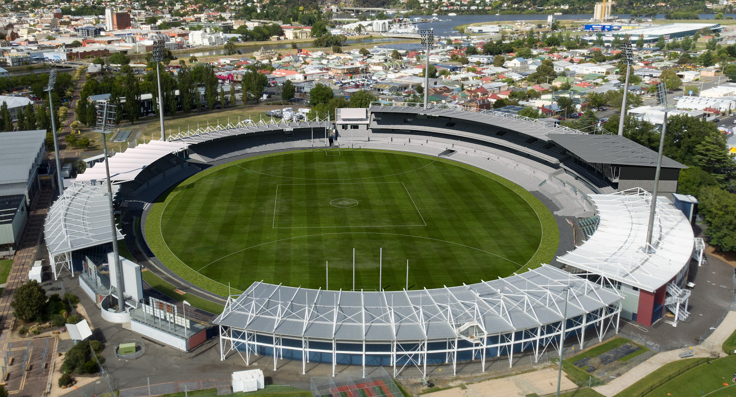

UTAS Stadium Redevelopment
Project on a Page
February 2024

The Australian and Tasmanian Government have each committed $65 million in funding to upgrade UTAS Stadium. The upgrades will deliver a contemporary facility in the heart of Launceston, securing Tasmania’s sporting future. The Department of State Growth through Infrastructure Tasmania is expected to begin construction in late 2024 with the works expected to be completed in 2027.

We’re improving the University of Tasmania Stadium in Launceston, an iconic precinct that has hosted great sporting events since 1921.

This transformation will attract national sporting and entertainment events to Launceston, supporting the City of Launceston’s vision to make it a premier business, retail and lifestyle hub.

The $130 million redevelopment will:

Better align it with Australian Tier 2 AFL venue guidelines.

Deliver new and improved spectator amenities and upgraded player, sporting team and match-day facilities.

Enhance the spectator experience by offering a better fan experience and atmosphere.

Increase economic outcomes by increasing the capacity to host content and increase visitation to Tasmania.

Deliver a more accessible and economically sustainable venue.

The Department of State Growth is continuing to work with key stakeholders and the broader community to refine the designs and confirm match day needs.

You can find more information on the project by visiting www.infrastructure.tas.gov.au or by emailing projects@infrastructure.tas.gov.au

Infrastructure Tasmania

