

Project Assurance  
Framework

**Infrastructure Tasmania**

Department of State Growth

# **Document control and approval**

|  |  |  |  |  |
| --- | --- | --- | --- | --- |
| No | Version | Date | Approval | Variations |
| 1 | 1.0 | May 2021 | Martin Blake  CEO, Infrastructure Tasmania |  |
| 2 | 1.1 | June 2024 | Ben Goodsir  CEO, Infrastructure Tasmania | Clarifies roles and responsibilities, strengthens information and confidentiality, clarifies payment and provides for incidental amendments |
| 3 | 2.0 | April 2025 | Ben Goodsir  General Manager, Infrastructure Tasmania | Confirms thresholds for mandatory reviews from 1 July 2025, ability to request voluntary reviews, and incidental amendments. |

**Contact for enquiries**

|  |  |
| --- | --- |
| Contact | Email |
| Infrastructure Tasmania | [Project.Assurance@stategrowth.tas.gov.au](mailto:Project.Assurance@stategrowth.tas.gov.au) |

# Contents

Document control and approval i

Contents ii

Background and purpose 1

Purpose of the framework 1

Framework objectives 2

Benefits 3

Framework application 3

Infrastructure Tasmania’s role 3

Assurance reviews 4

Treatment of projects and programs 5

Gate reviews, health checks and deep dives 6

Recommended reviews by project tier 6

Project lifecycle 7

Framework operations 8

Conducting a review 8

Assurance roles and responsibilities 9

Draft and final review report 10

Progress report for recommendations 10

Improving infrastructure outcomes 10

Confidentiality 11

Report ownership and disclosure 11

Glossary 12

Appendix A – Assurance review reporting and rating 14

Appendix B – Risk profile criteria and risk score matrix 16

# Background and purpose

Project assurance first originated in the United Kingdom to help the government deliver successful information technology projects. It was expanded to cover all UK Government infrastructure delivery projects and has been used as a best practice template to support public sector delivery ever since. Over the past two decades, governments across Australia have adopted project assurance reviews to inform public sector investment decisions and obtain increased oversight throughout project development and delivery.

In 2022, the Tasmanian Government endorsed a project assurance function to monitor infrastructure delivery and delivery capacity. This became a mandated approach from 1 July 2025 with key objectives including:

* strengthening and supporting the successful delivery of government capital infrastructure investment projects
* regular monitoring and reporting on capital infrastructure project/program delivery.

This document outlines the project assurance framework, the role of Infrastructure Tasmania (ITas) in coordinating project assurance activities, and its responsibilities for managing and delivering the framework.

## **Purpose of the framework**

Project assurance is a critical part of identifying and managing project and program risk to ensure objectives can be successfully delivered.

For the purposes of the framework, project assurance is defined as the governance, reporting and independent expert project review process that assesses the health and viability of a project. Project assurance helps manage risk and improves delivery confidence.

This framework provides a structured approach for the independent assessment of the health and viability of projects/programs and focuses on:

* gate assurance reviews
* health checks and deep dives
* infrastructure project reporting.

Project assurance is not an audit, approval or endorsement process. It is a process that supports project development and delivery to minimise the risk of project failure and improve project management skills and systems.

# Framework objectives

This framework has been developed to achieve the following objectives.

1. A single source of independent project assurance across capital infrastructure projects/programs, providing strong and consistent advice to government.
2. Informed decision making, supporting government as an investor through improved data collection and analytics.
3. A flexible risk-based approach focusing on what matters, considering project/program specific needs.
4. Monitoring and reporting leading to the review and continuous improvement of existing processes and policies.
5. Collaboration and support through sharing resources, processes and insights across agencies to improve delivery and learn from experience.
6. Value to agencies by identifying issues early and providing practical advice.

The framework does not remove delivery agency responsibility to comply with Tasmanian Government procurement and governance requirements.

**Project Assurance Framework in the context of existing guidelines**

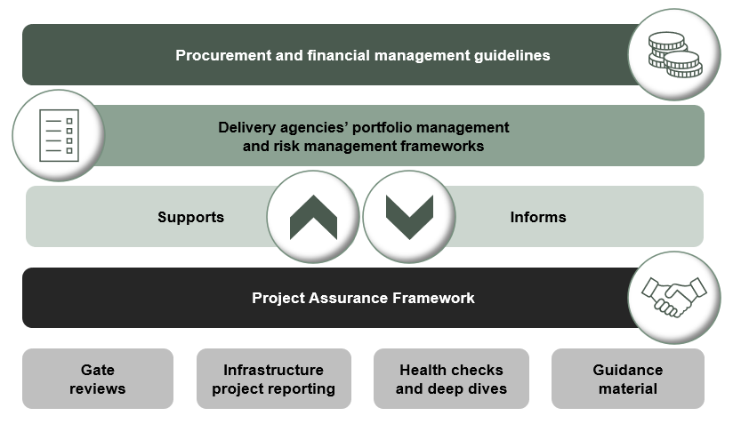

## **Benefits**

Implementing a consistent approach to project assurance across all major infrastructure projects will support:

* Transparency in project and program planning, delivery risks and progress, which allows for informed decision making.
* Consistent application of good practice methodologies and principles in delivery, which improves project and program management capability within the public sector.
* Early identification of risks and issues that may impact outcomes or viability.
* A focus on delivering outcomes from infrastructure investments, rather than just outputs.
* Experience and lessons learned being shared across government.
* Increased confidence in the timely provision of value for money infrastructure that meets community needs.

## **Framework application**

The framework applies to all infrastructure projects valued at $50 million and above, being developed and/or delivered by Tasmanian Government agencies.

Infrastructure projects valued over $10 million can be referred for review at the discretion of Budget Committee, portfolio ministers or heads of agencies.

The framework does not operate in isolation and is intended to complement existing risk controls already in place at an agency level. It has been developed with the objective of supporting agencies to deliver better outcomes when implementing infrastructure projects and programs.

## **Infrastructure Tasmania’s role**

ITas will administer, coordinate and maintain the framework and its guidance material on behalf of the Tasmanian Government.

ITas will maintain a register of all applicable capital projects. It is mandatory for delivery agencies to register their relevant/eligible projects and actively engage with ITas prior to the start of project development. The registration process will include a high-level risk assessment, determine the reviews to be undertaken and the level of project reporting and monitoring required.

Delivery agencies are responsible for ensuring data and information on registered projects remain up-to-date and accurate.

ITas will also provide advice to the Tasmanian Government as appropriate, including regular project assurance reporting covering common trends and insights identified through implementation of the framework.

# Assurance reviews

The framework includes four components:

* gate reviews (Gate 0 to Gate 6)
* health checks
* deep dives
* regular project progress reporting.

Reviews are linked to specific stages of the project lifecycle, to inform key decisions before progressing to the next stage. Similarly, health checks have a specific focus on common delivery issues or risks, to inform the readiness for the next project stage.

Assurance activities across the project lifecycle

|  |  |  |  |  |  |  |  |  |
| --- | --- | --- | --- | --- | --- | --- | --- | --- |
| Project phase | **Initiate** | **Plan and development** | | **Procurement** | | **Execute** | | **Close** |
| Lifecycle phase | Establish mandate | Strategic analysis | Investment decision | Prepare for market | Competitive procurement | Award contract and delivery | | Completion |
| Gate reviews | **Gate 0**  **Project registration** | **Gate 1**  **Project justification** | **Gate 2**  **Business case** | **Gate 3**  **Readiness for market** | **Gate 4**  **Tender evaluation** | **Gate 5**  **Readiness for service** | | **Gate 6**  **Benefits realisation** |
| Health checks | Development | | | Procurement | | Delivery | |  |
| Deep dives | Technical and specific scope as required | | | | | | | |
| Senior Responsible Officer | Sponsor agency | | | Delivery agency | | |  | |
|  | | | | | Asset manager / owner operator | | |

## **Treatment of projects and programs**

The framework can apply to programs and projects.

Projects can be consolidated into a program and progressed. However once programs are more progressed and have an approved business case in place (Gate 2), the program may be separated into individual projects with each having individual timing, funding and staging requirements. The individual projects will be assessed using the risk profiling tool to assess their assurance requirements. The separated projects may then be consolidated back into a program at Gate 6 to assess the benefits of the program in its entirety.

Project registration (Gate 0) and risk profile assessment

An initial risk profile assessment conducted as part of registration with ITas provides an indication of the assurance needs for the life of the program or project. There is no requirement to complete every gate review - the activities required can be tailored using a risk-based approach. At project registration a risk-based assessment considers the following criteria:

* government priority
* agency capability and capacity
* funding and procurement complexity
* 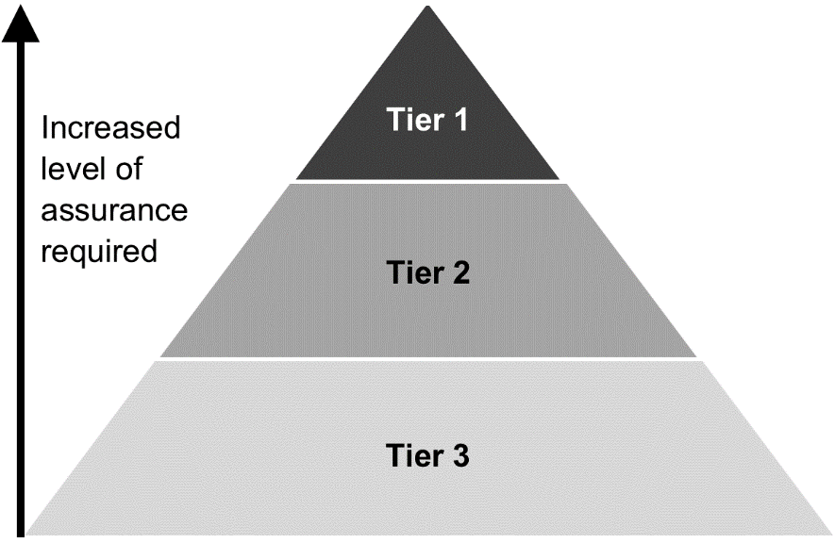project interface complexity
* stakeholders and approvals complexity
* environmental and sustainability complexity.

Based on the weighted risk score across these criteria, and the total estimated budget, projects can be categorised into one of three tiers:

* Tier 1 – High value and high risk
* Tier 2 – Medium risk
* Tier 3 – Low risk

Based on the tier, an assurance plan (Gate 0 Report) is developed to determine the gate reviews, health checks and deep dives for each project or program. A higher level of scrutiny is recommended for Tier 1 – High value and high-risk projects.

See Appendix B for the project tier weighted risk score matrix and detailed risk criteria.

|  |
| --- |
| Example: A ‘community centre upgrade’ project with a budget of $30 million, delivered by an agency with significant experience successfully delivering similar projects, and minimal project risks may be classed as a Tier 3 project. A ‘stadium upgrade’ project with a $30 million budget may be classed as a Tier 1 project based on multiple external stakeholder partners involved in delivery and uncertain approval and procurement complexities which add to the project risk. |

## **Gate reviews, health checks and deep dives**

Gate reviews provide short, focused, independent expert reviews at key decision points. The reviews will highlight risks and issues that may threaten successful delivery and provide recommendations to assist delivery. The reviews are supported by guidance material to ensure a standardised and robust approach.

Health checks may be conducted at any time but are most useful when there are long periods between gates. Health checks can identify any emerging issues between key decision points and are undertaken.

Deep dives focus on specific issues anywhere along the project lifecycle and can provide a more technical assessment of issues faced by a project.

### Recommended reviews by project tier

This framework recommends key gate reviews be completed based on the assessed risk tier.

Despite the recommendation that all Tier 1 projects undertake all six recommended gate reviews, a flexible approach is important and the need for further reviews is assessed at each gate review.

|  |  |  |  |
| --- | --- | --- | --- |
| Gate reviews | Tier 1 | Tier 2 | Tier 3 |
| **Gate 0 – Project registration** | R | R | R |
| **Gate 1 – Project justification** | R | R | O |
| **Gate 2 – Business case** | R | R | O |
| **Gate 3 – Readiness for market** | R | O | O |
| **Gate 4 – Tender evaluation** | R | O | O |
| **Gate 5 – Readiness for service** | R | O | O |
| **Gate 6 –Benefits realisation** | R | R | R |
| Health checks | | | |
| Delivery | R | R | O |
| Deep dives | | | |
| Any phase | O | O | O |
| Other assurance activities | | | |
| Regular progress reporting | R | R | R |

R= Recommended; O= Optional

## **Project lifecycle and gate review stages**

|  |  |  |  |
| --- | --- | --- | --- |
|  | **Activities** |  | **Gate** |
| **Initiate** | **Establish mandate** | 🡪 | **0 – Project registration** |
| * Decision to initiate project. |  | * Registration with ITas. * Completion of Gate 0 report template including risk profile assessment and preliminary project assurance plan. |
| **Plan and development** | **Strategic analysis** | 🡪 | **1 – Project justification** |
| * Develop strategic case. * Consider options. * Conduct investment logic mapping. |  | * Well defined service need. * Evidence of how the project scope meets the service need. * Appropriate level of options and  cost-benefit analysis. |
| **Develop business case** | 🡪 | **2 – Business case** |
| * Identify and appraise options. * Establish affordability, deliverability and value for money. * Develop project brief. * Develop procurement strategy. |  | * Completed business case, including detailed risk plan, cost plan and cost-benefit analysis. |
| **Procurement** | **Prepare for market** | 🡪 | **3 – Readiness for market** |
| * Specify requirements and finalise procurement documentation. |  | * Scope definition. * Procurement documentation and commercial approach. * Evaluation strategy/plan. * Probity plan. |
| **Competitive procurement** | 🡪 | **4 – Tender evaluation** |
| * Release tender. * Evaluate bids and select supplier. * Confirm final costings (including contingencies) and update business case. |  | * Evaluation report. * Probity report. * Summary of variations. * Evidence of delivery readiness and handover approach. |
| **Execute** | **Award contract** | 🡪 | **5 – Readiness for service** |
| * Award contract and commence contract management. * Construct or deliver asset. * Establish handover plans. * Obtain independent verifier report to confirm scope delivery. |  | * Independent verifier reports confirming scope delivery. * Testing and commissioning documentation. * Operational readiness documentation. * Handover strategy. |
| **Close** | **Reporting** | 🡪 | **6 – Benefits realisation** |
| * Confirm purpose and functionality. * Identify if project on track to meet benefits. * Report against benefits realisation plan. |  | * Evidence of operational performance. * Records of lessons learnt. * Benefits realisation plan. |

# Framework operations

## **Conducting a review**

The table shows a high-level overview of the steps from project registration to finalising a review. Reviews can take from four to six weeks to complete. Refer to the specific workbook of the review being undertaken for more details.

## Assurance roles and responsibilities

The framework applies the following roles and associated responsibilities.

|  |  |  |
| --- | --- | --- |
|  | Role | Responsibility |
| Senior Responsible Officer (SRO) | The delivery agency executive (usually the Secretary or Deputy Secretary) with strategic responsibility, who is the single point of overall accountability for project, including responsibility for governance and of benefits. | * Delegate (in writing) appropriate work activities to the project team. * Endorse the project risk profiling assessment, and agree to the terms of reference, names of interviewees and documents shared with ITas. * Actively engage with ITas and the assurance review team, including fact checking queries. * Provide responses to the draft report recommendations. * Owns and is responsible for addressing or remedying any recommendations in the final report. |
| Assurance Review Team | To undertake a gate review, health check or deep dive in line with the agreed terms of reference. | * Undertake a confidential, independent assurance review in line with the terms of reference. * Write a draft and final report setting out the findings and reasoning for the assurance review and share with ITas and the SRO. |
| Delivery agency | To develop and/or deliver a project that will undergo a gate review, health check or deep dive. | * Nominate an SRO. * Make resources available to support successful delivery of the project. |
| Infrastructure Tasmania (ITas) | To administer and review the framework. | * Work with delivery agencies to ensure that a project is risk profiled and assigned a risk-based tier rating. * Establish and administer project assurance panel comprising experts with skills, experience and capability across relevant infrastructure sectors and project delivery. * Appoint Assurance Review Teams with expertise specific to each project. * Guide and coordinate the gate review, health check or deep dive. * Monitor quality, scope and consistency of assurance reviews.   (continued over)   * Provide regular high-level performance reports to agencies and government, including commentary on recommendations, as/if required. * Collect and analyse data and insights to identify common issues, common themes, data trends and analytics to be included in an annual report. * Work with agencies, industry and assurance review teams on how to best address challenges at a whole of government level. * Explore opportunities to share lessons and insights across government agencies and project management communities. * Maintain and continuously review policy, process and provide advice to government. |

## Draft and final review report

The Assurance Review Team will prepare a draft review report and provide it to ITas to maintain independence from the project. ITas share the report with the SRO.

The SRO is then responsible for:

* Checking the report for factual accuracy and provides marked-up corrections of any factual issues in the commentary. This does not extend to challenging or rewriting review team observations, professional opinions or recommendations.
* Providing initial responses to the recommendations made in the draft report in the table provided.
* Returning report to ITas which will liaise with the review team for finalisation.

The report only becomes final once the review team has reviewed and approved the updated report and the agency’s responses.

ITas will send a copy of the final review report to the SRO.

## **Progress report for recommendations**

The final review report will include a set of recommendations supported by key findings. A progress report is prepared by the project team to address these recommendations.

ITas will monitor progress towards completing these recommendations. This progress, and common themes, will inform regular reporting to Government.

## **Improving infrastructure outcomes**

ITas will use trends and insights from assurance reviews to work with agencies, industry and review teams to identify how to best address challenges at a whole of government level. ITas will explore opportunities to share lessons and insights across government agencies and the project management community.

# Confidentiality

All project information is owned by the delivery agency, even when the information has been supplied to ITas and used as part of a project assurance review.

The confidentiality of the process and final report allows interviewees to openly raise issues without names or roles being identified. As part of the process, both ITas and the review team destroys all documentation at the end of the review.

## Report **ownership and disclosure**

The delivery agency owns the reports prepared by the review team. Disclosure of a report risks undermining the integrity and validity of the assurance review and its purpose, which is to provide clear and honest advice. This is essential to ensure review outcomes are reliable and credible, so that the SRO can make appropriate decisions on any action needed.

ITas retains a copy for reporting purposes but does not distribute the reports without the written consent of the SRO. Only staff with a direct role to manage or coordinate assurance reviews can access records. ITas uses its copy to:

* report on metrics and analytics from aggregated project assurance reviews
* identify trends affecting the performance of infrastructure projects, key drivers of risk, challenges and opportunities associated with the infrastructure investment program
* monitor the recommendations provided and follow up with delivery agencies on the status of addressing those recommendations as/if required and
* use as background for a subsequent assurance review for the same project or program.

# Glossary

|  |  |
| --- | --- |
| Term | Definition |
| **assurance reviews** | Refers to gate review, health checks and deep dives. |
| **Assurance Review Team** | A team of expert independent reviewers, sourced from the Project Assurance Services Panel engaged by Infrastructure Tasmania to undertake a gate review, health check or deep dive. |
| **deep dive** | Deep dive reviews are similar to health checks but focus on a specific and often technical issue. These reviews are usually undertaken in response to an issue raised by project teams, SROs, Cabinet or the like. |
| **delivery agency** | The government agency tasked with developing and/or delivering a project. |
| **gate** | Key decision point(s) in a project/program’s lifecycle when a gate review may be undertaken. |
| **gate review** | A review of a project/program by an independent team of experienced practitioners at a specific key decision point (gate) in the project/program lifecycle.  A gate review is a short, focused, independent expert appraisal of the project/program that highlights risks and issues, which if not addressed may threaten successful delivery. It provides a view of the current progress of a project/program and assurance that it can proceed successfully to the next stage if any critical recommendations are addressed. |
| **health check** | A health check is an independent review carried out by a team of experienced practitioners seeking to identify issues in a project/program which may arise between gate reviews. |
| **program** | Programs provide an umbrella under which related projects and activities can be coordinated. A program is likely to be longer term and have a life that spans several years.  Projects that form part of a program may be grouped together for a variety of reasons including co-location, similar nature (for example, agency capital program or road upgrades) or shared outcome.  The component parts of a program are usually individual projects or smaller groups of projects (sub-programs). In some cases, these individual projects or sub-programs may have a different project tier to the overall program. |
| **project** | A project is a group of interrelated activities that are planned and then executed in a particular sequence to achieve planned and agreed outcomes, within a predetermined timeframe. A particular project may or may not be part of a program. A project has the following characteristics:  • defined scope and finite resources  • has a definable start and end dates  • introduces a change  • creates a unique result, product or service  • has its own governance structure |
| **project assurance** | The governance, reporting and independent expert project review process that assesses the health and viability of a project. Project assurance can provide investors and other stakeholders with the confidence that the project can deliver to time, budget and quality. |
| **Project Assurance Services Panel** | Established and managed by Infrastructure Tasmania, the panel includes experts with skills, experience and capability across infrastructure sectors and project delivery. The project assurances service panel ensures quick mobilisation and coordination of review teams and the consistent application of the project assurance framework. |
| **project tier** | The project tier classification is comprised of three project tiers, where Tier 1 encompasses projects deemed as being the highest risk profile (Tier 1 – high value, high risk projects), and Tier 3 with the lowest risk profile. Tier classification considers a project's overall risk profile and the project’s estimated total budget. |
| **regular infrastructure project reporting** | Routine reporting of projects prepared by the Department of Treasury and Finance and provided to government. |
| **Senior Responsible Officer (SRO)** | The delivery agency secretary or deputy secretary with strategic responsibility and the single point of overall accountability for a project/program. The Senior Responsible Officer (SRO) is the owner of the business case, accountable for all aspects of governance and delivery of benefits. Some project management methodologies refer to this role as the Project Executive, Sponsor or Client. |

# Appendix A – Assurance review reporting and rating

Every review report will provide an overall confidence rating for the overall project and a rating for individual recommendations. This ensures recommendations are focussed on criticality for project success while still capturing opportunities to embed good practice across project delivery and leadership.

A Red, Amber, Green rating will be used as described below.

**Overall rating key (confidence in successful delivery)**

|  |  |  |
| --- | --- | --- |
| Low | Successful delivery of the project is in doubt, with major risks or issues apparent in a number of key areas. Urgent additional action is needed. | The project may need re-baselining and/or the overall viability reassessed. |
| Medium | Successful delivery is feasible but significant issues exist which require timely management attention. | These issues appear resolvable at this stage and, if addressed promptly, should not impact on cost, time or quality |
| High | Successful delivery of the project to time, cost and quality appears highly likely. | There are no major outstanding issues that at this stage appear to threaten successful delivery. |

**Individual recommendations (criticality)**

|  |  |
| --- | --- |
| Critical | Action required. This item is critical and urgent. The project team should act immediately. |
| Essential | The recommendation is important but not urgent. The project team should act before further key decisions are taken. |
| Good practice | The recommendation is not considered critical or urgent, but the project may benefit from implementing this recommendation. |

**Key focus areas**

Each report will provide an assessment of the following key focus areas:

* service need
* value for money and affordability
* governance
* risk management
* stakeholder management
* asset owner's needs and change management
* social, economic and environmental sustainability.

The key focus areas are rated using the following definitions:

|  |  |
| --- | --- |
| Strong | There are no major outstanding issues that at this stage appear to threaten delivery. |
| Satisfactory | There are issues that require timely management attention. |
| Weak | There are significant issues in this key focus area that may jeopardise the successful delivery of the project. |

# Appendix B – Risk profile criteria and risk score matrix

ITas has developed an excel-based risk profiling assessment tool which is completed by the delivery agency when registering a project.

The process involves giving each project a score against a set of risk assessment criteria and providing key information such as total estimated cost. The risk profiling assessment tool calculates the weighted risk score and determines the risk-based project tier in line with Table 1.

The risk assessment considers six criteria:

* government priority (20%)
* agency capability and capacity (20%)
* funding and procurement complexity (15%)
* project interface complexity (20%)
* stakeholders and approvals complexity (15%)
* environmental and sustainability complexity (10%).

The criteria are scored from 5 (very high) to very low (1) using the risk profiling assessment tool. Guidance on scoring is available to agencies.

**Table 1 weighted risk score matrix**

|  |  |  |  |  |  |
| --- | --- | --- | --- | --- | --- |
| Weighted risk  score | Estimated total cost range | | | | |
| $5M – $10M | $10M-$50M | $50M-$100M | $100M-$500M | >$500M |
| 0.0 - 2.0 | Tier 3 | Tier 3 | Tier 2 | Tier 2 | Tier 2 |
| 2.1 - 2.2 | Tier 3 | Tier 3 | Tier 2 | Tier 2 | Tier 1 |
| 2.3 - 2.4 | Tier 3 | Tier 2 | Tier 2 | Tier 1 | Tier 1 |
| 2.5 - 2.9 | Tier 2 | Tier 2 | Tier 1 | Tier 1 | Tier 1 |
| 3.0 – 3.9 | Tier 2 | Tier 1 | Tier 1 | Tier 1 | Tier 1 |
| 4.0 – 5.0 | Tier 1 | Tier 1 | Tier 1 | Tier 1 | Tier 1 |



**Department of State Growth**

Level 1, 2 Salamanca Square  
Battery Point, TAS 7004

Phone: 03 6166 3181

Email: project.assurance@stategrowth.tas.gov.au

Web: www.infrastructure.tas.gov.au

© State of Tasmania